

***FROM ETHNUS***

***BUILDING FACE DETECTION APP USING AWS***

**Name: Kalahastri Jaswanth**

**College: VIT**

**Mail: kalahastrijaswanth@gmail.com**

***AMAZON WEB SERVIES(AWS)***

1. ***AWS Login screen with Username***

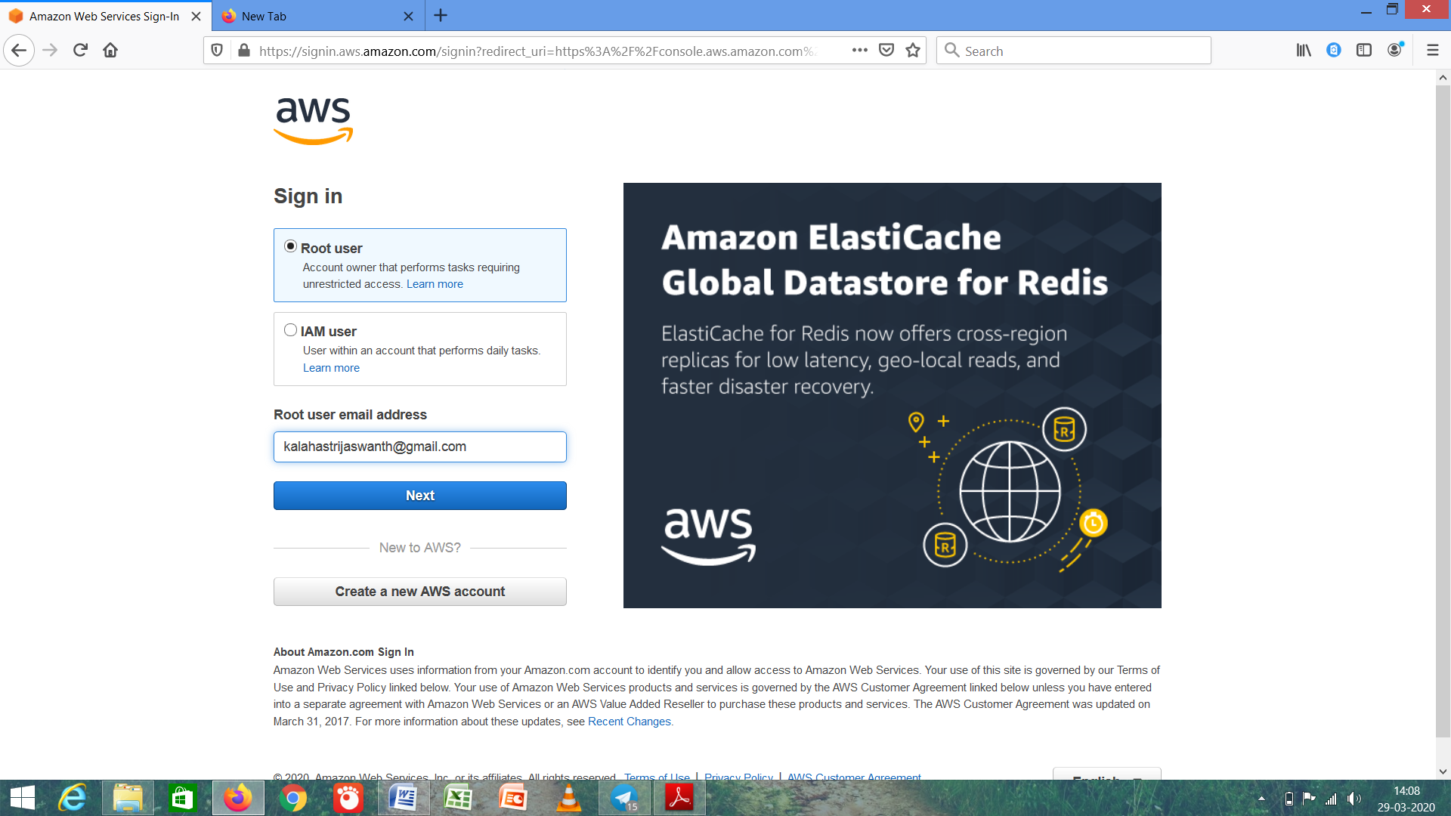

This is the AWS login screen and the username is kalahastrijaswanth@gmail.com

1. ***EC2 Dashboard***

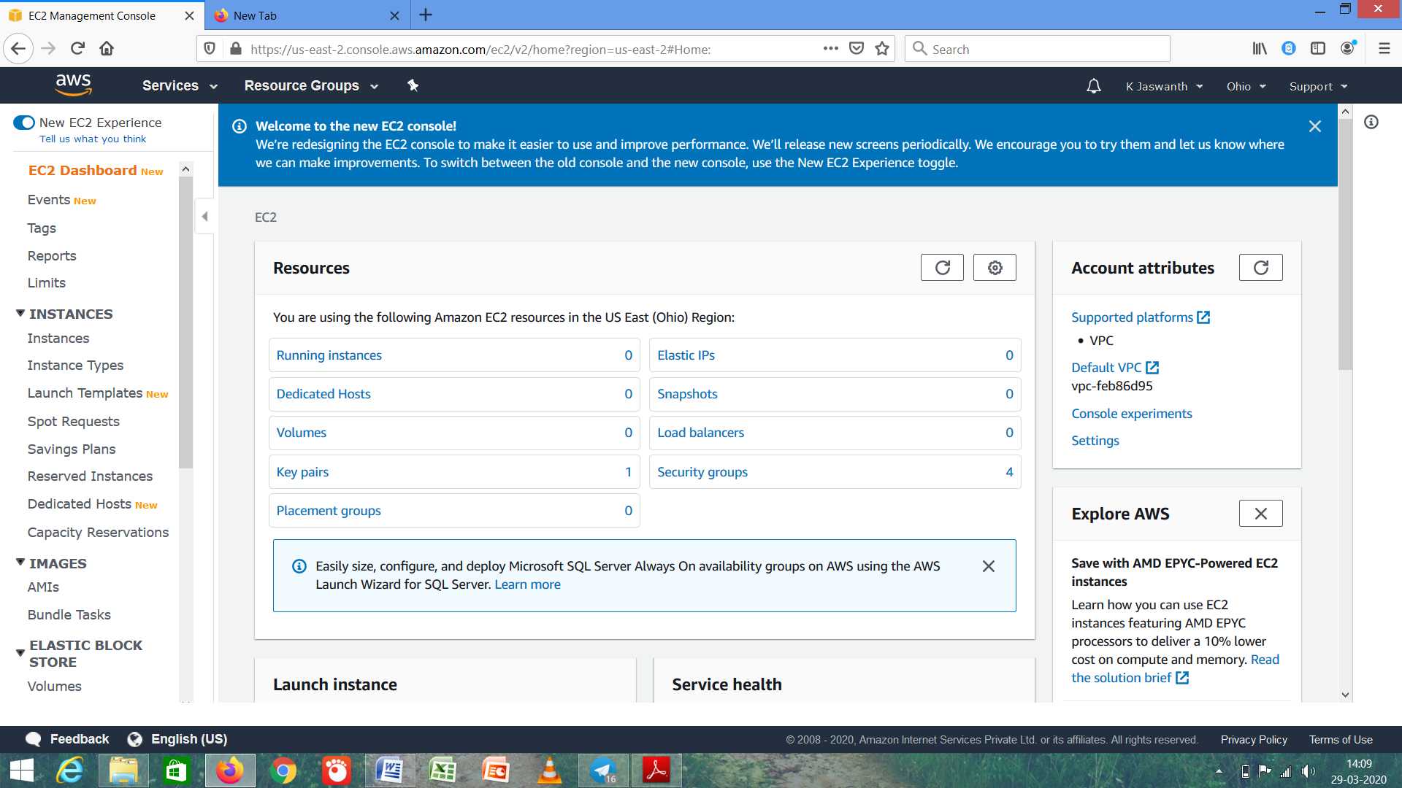

EC2 Dashboard and the name is K Jaswanth.

1. ***S3 Dashboard***

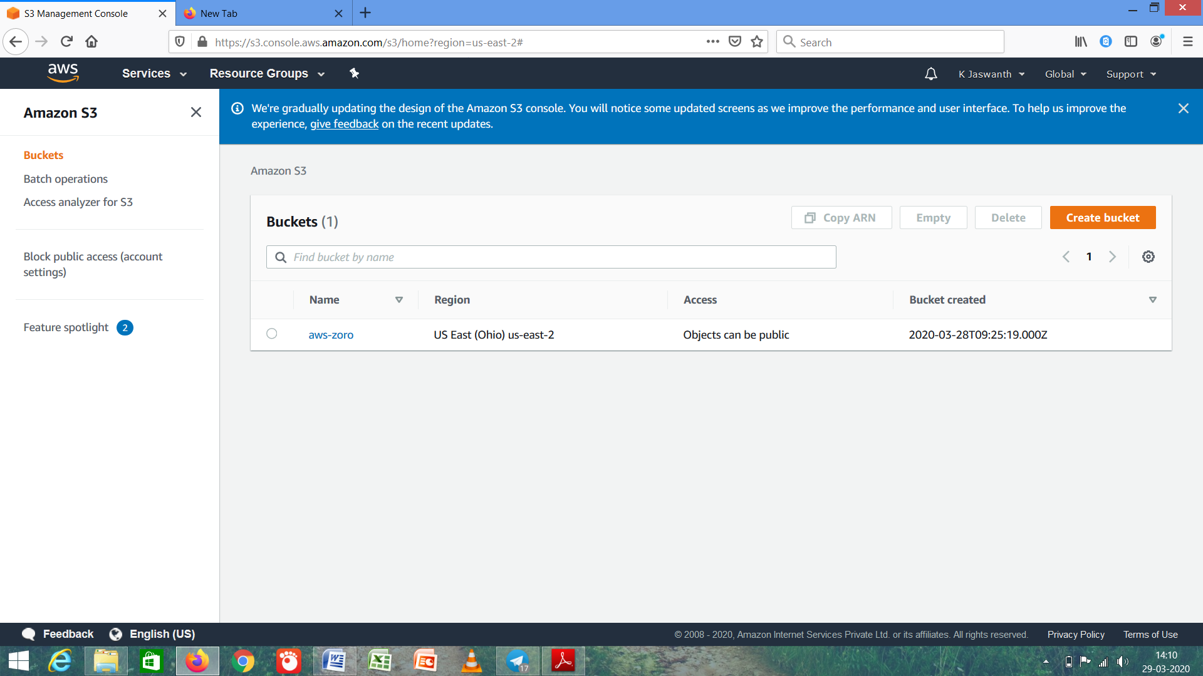



1. ***Rekognition Dashboard***

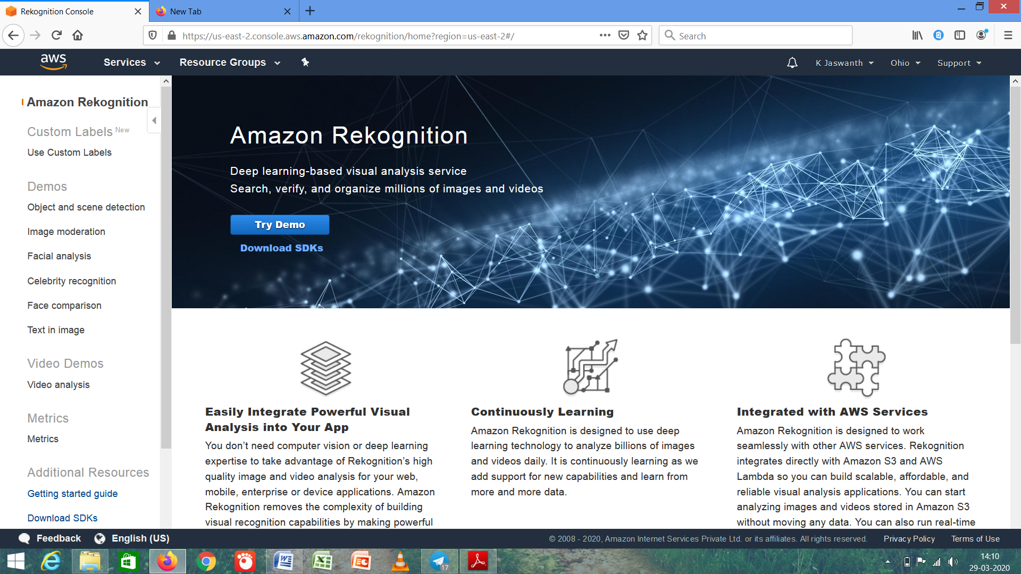

***AMAZON ELASTIC COMPUTE CLOUD (*EC2*)***

1. ***Choosing an AMI (Free Tier)***

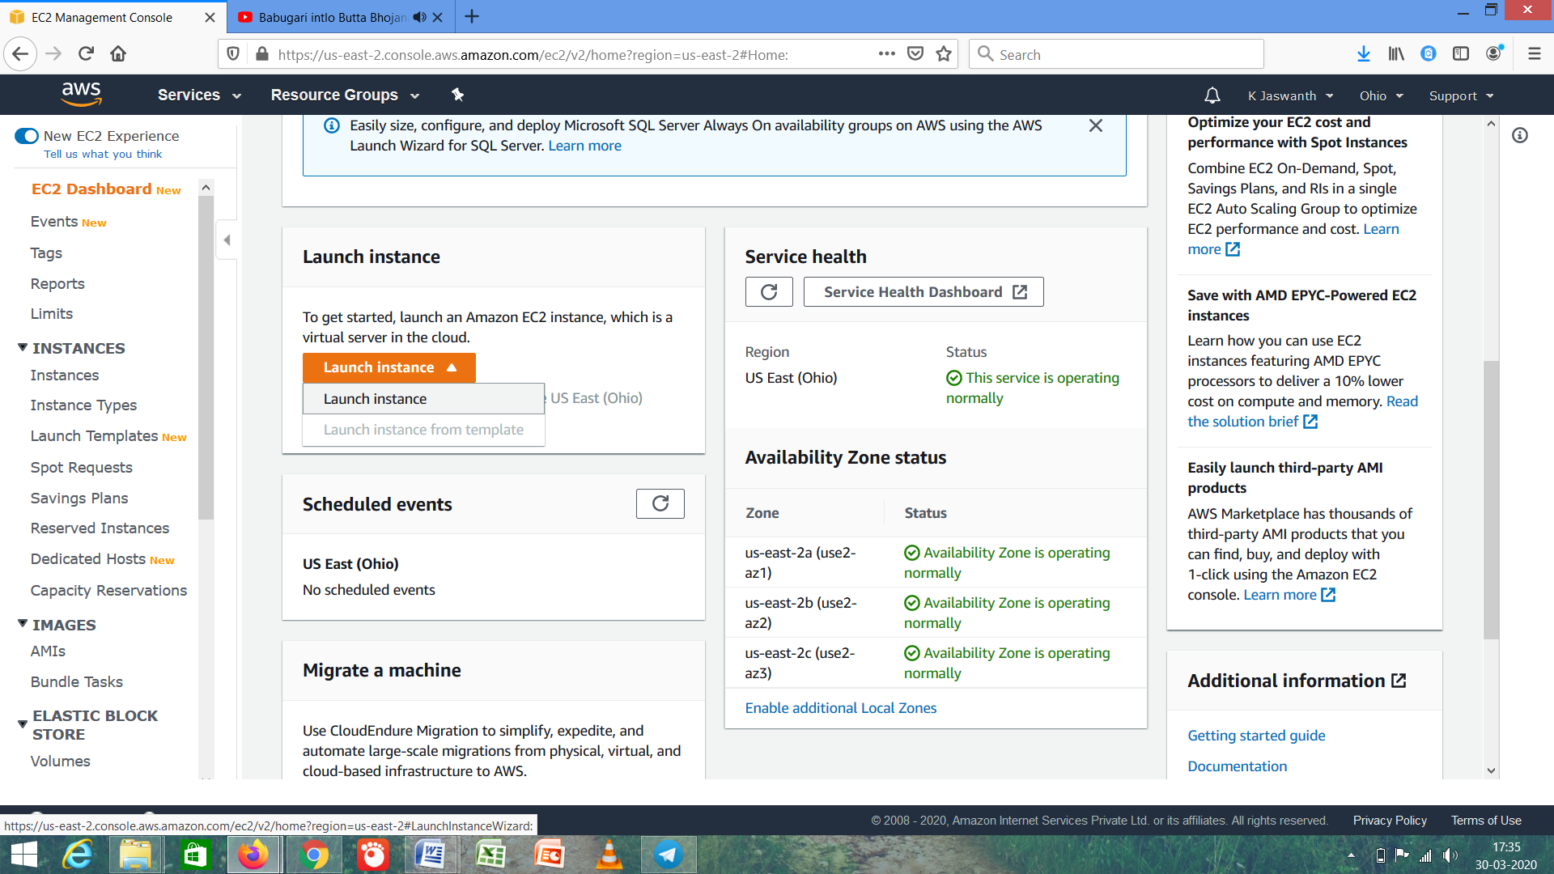

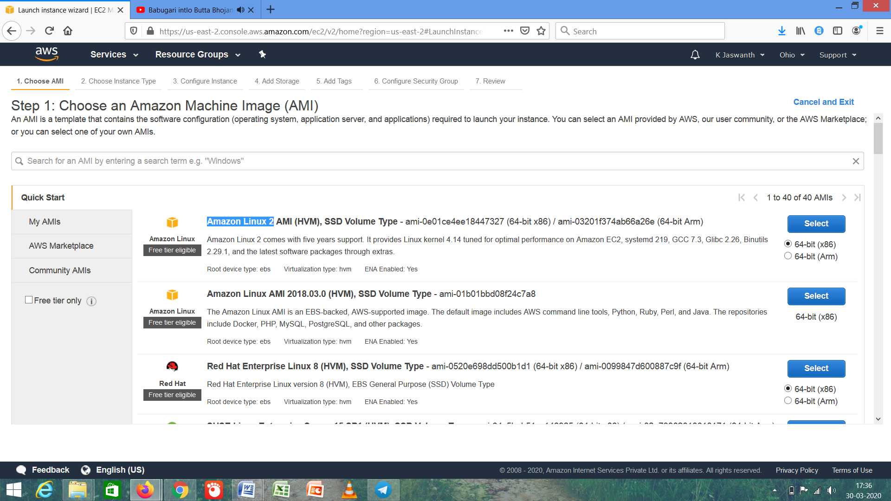

1. ***Choosing an Instance Type (t2 micro)***

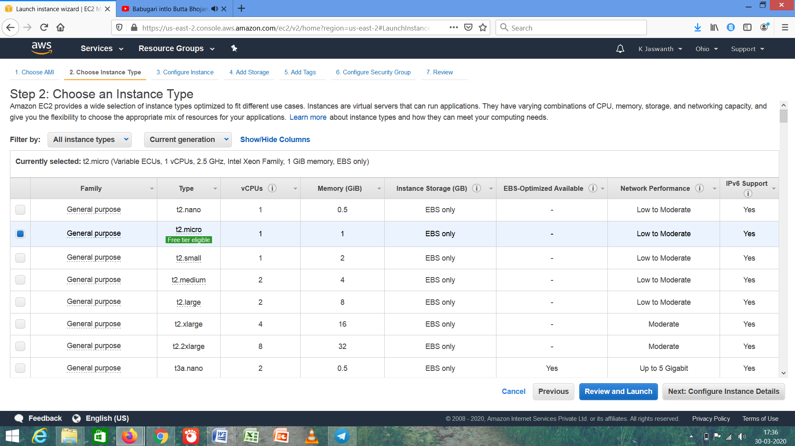

The instance type is t2 micro and general purpose family and has 1 CPU and RAM of 1GB.

1. ***Adding Storage (8GB,SSD)***

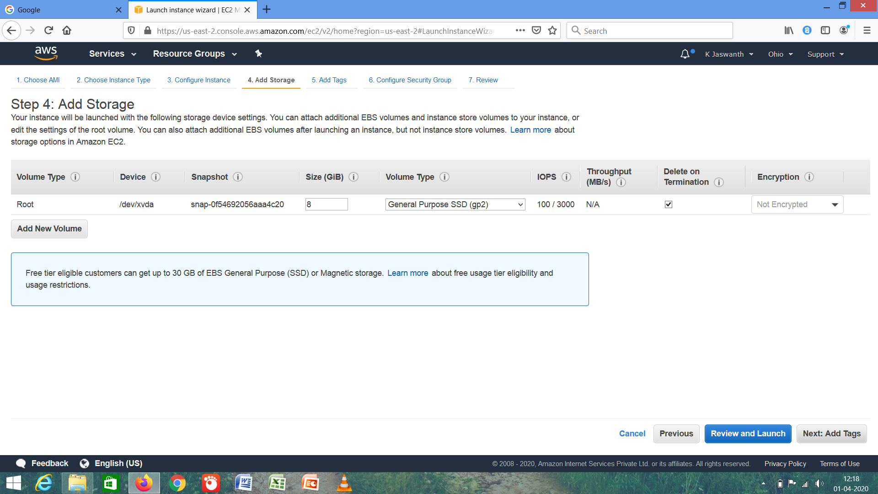

It acts as a storage device which is known as hard disk for our instance .

1. ***Configure Security Group***

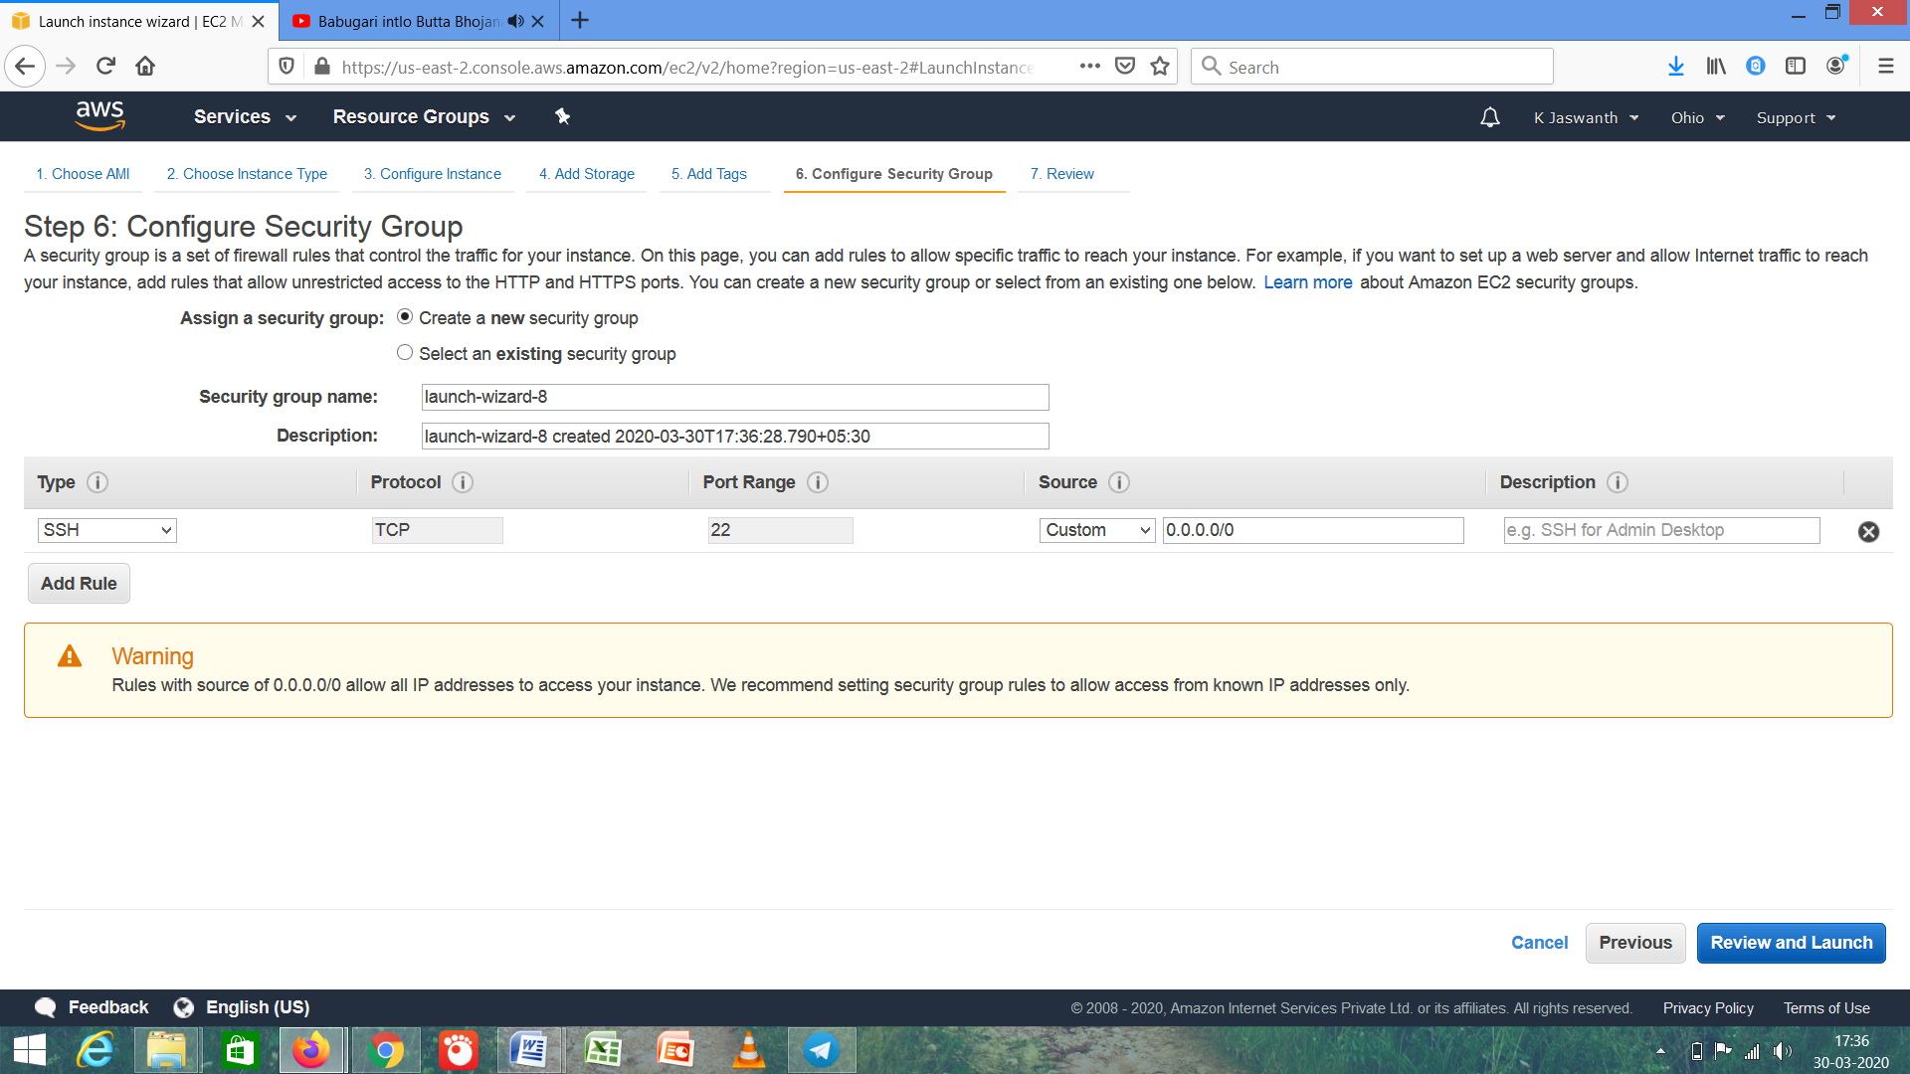

The security group uses type SSH and has a port range 22.

1. ***Key Pair Download***

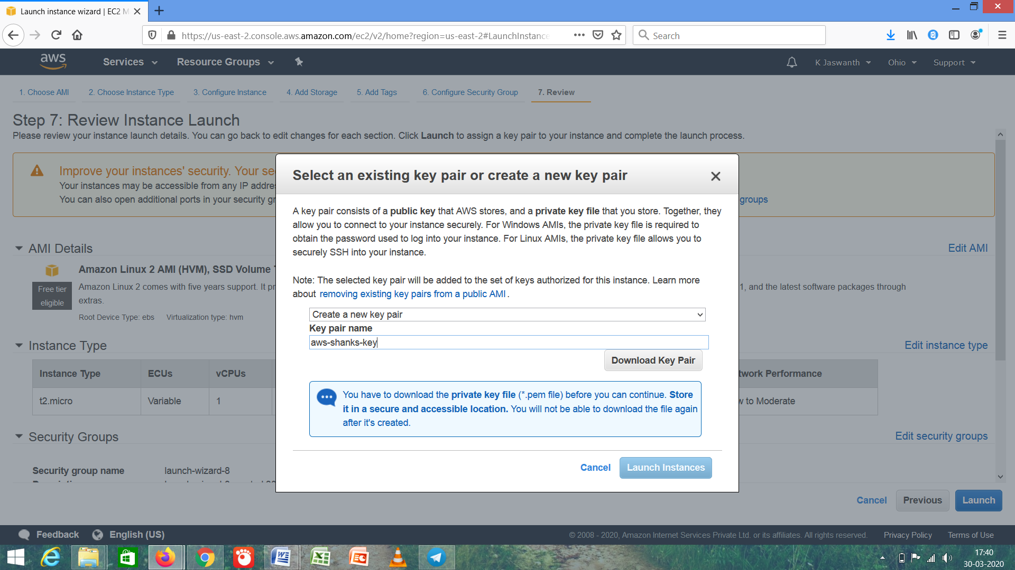

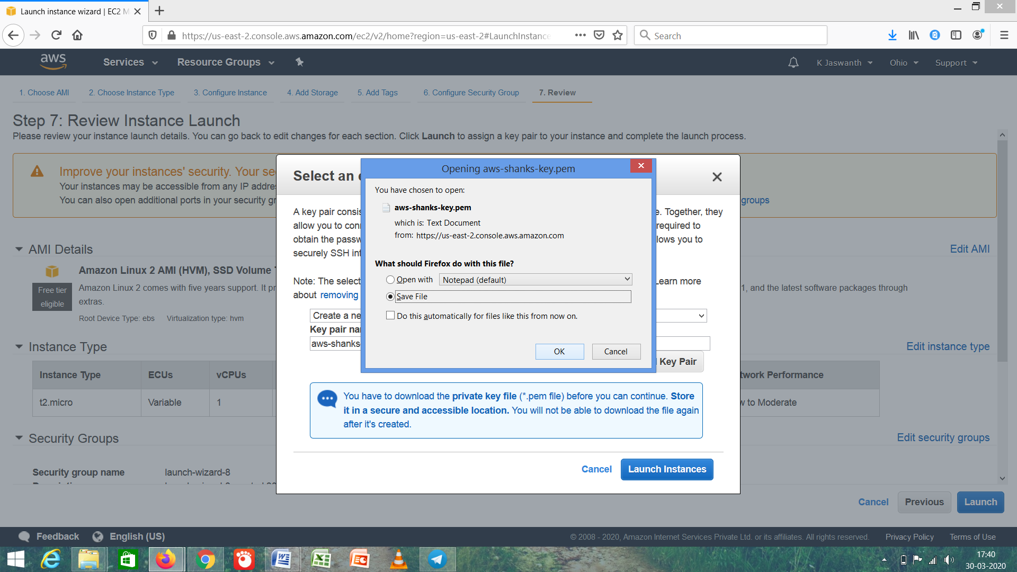

1. ***Puttygen Conversion from pem to ppk***

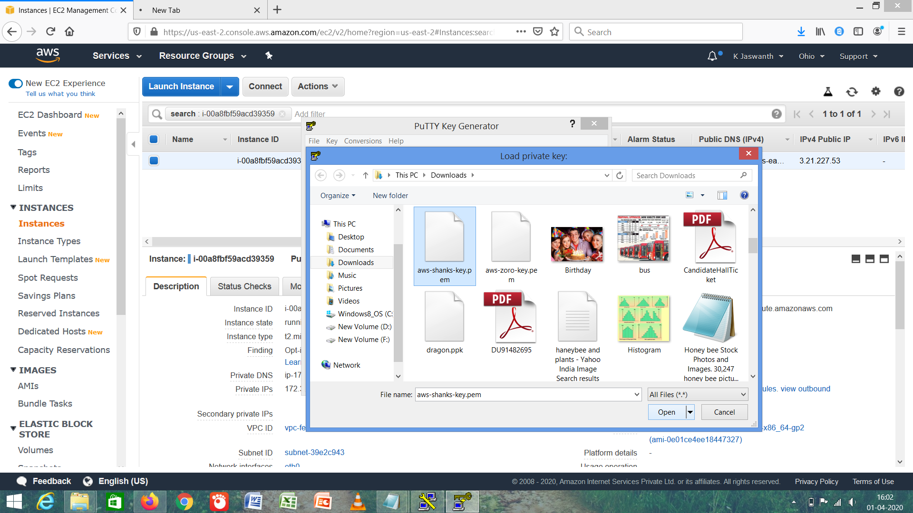

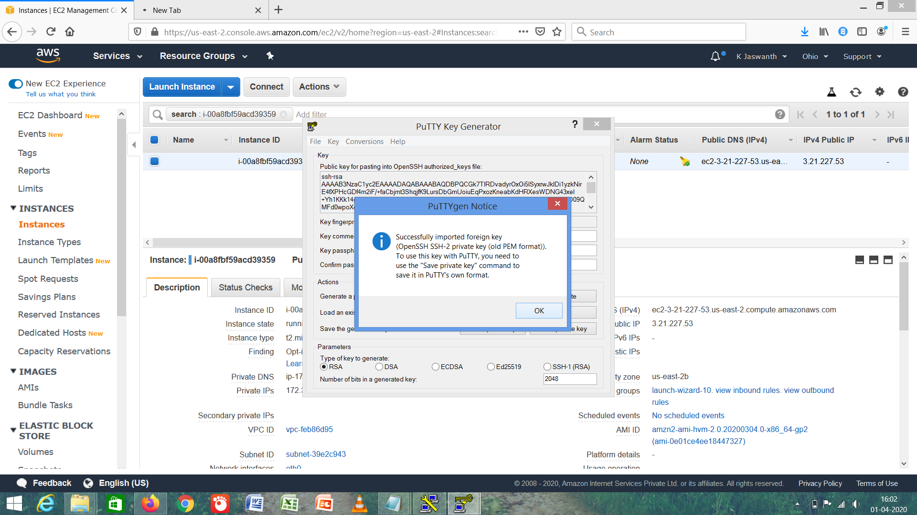

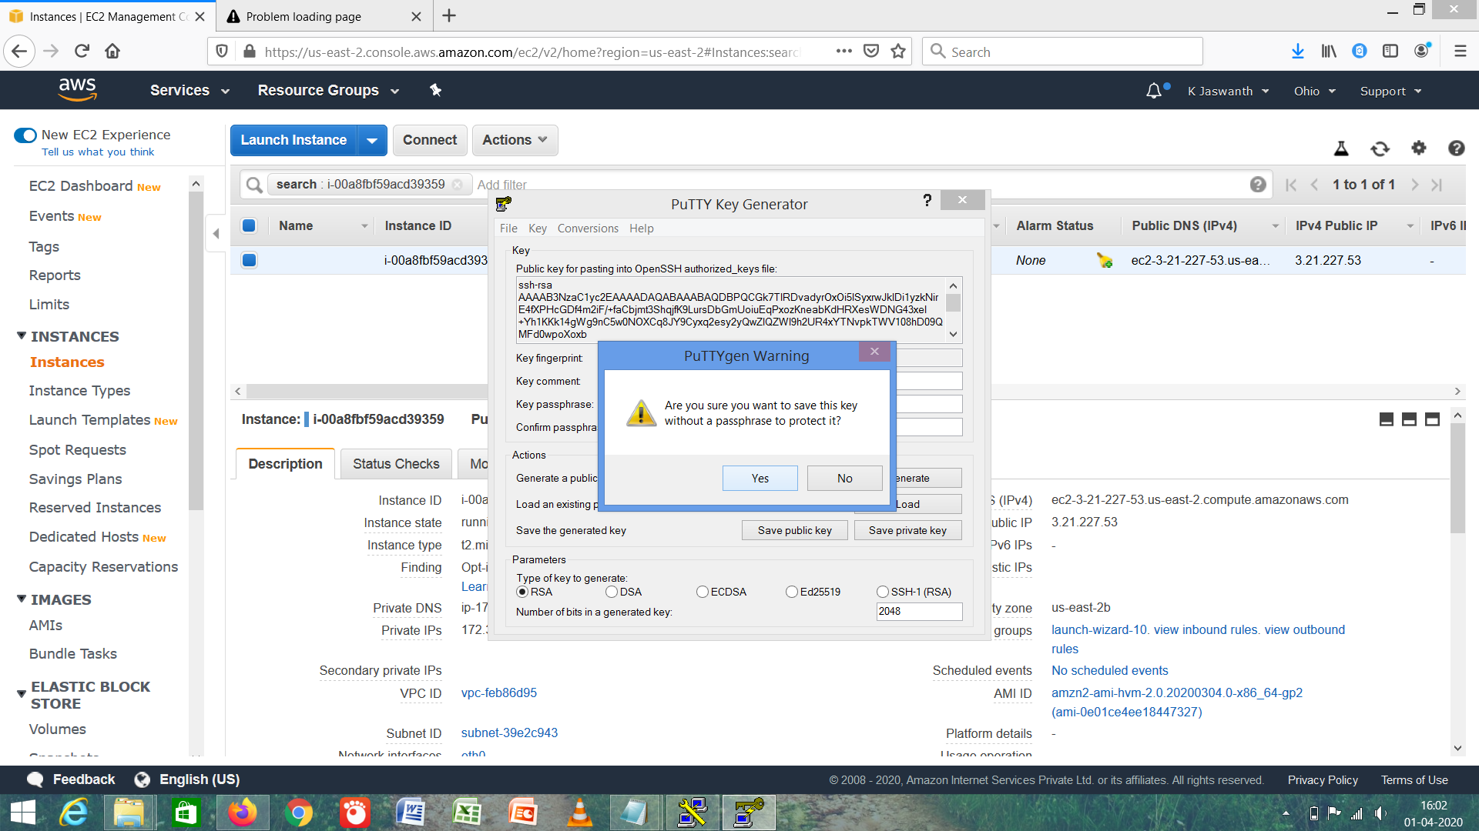

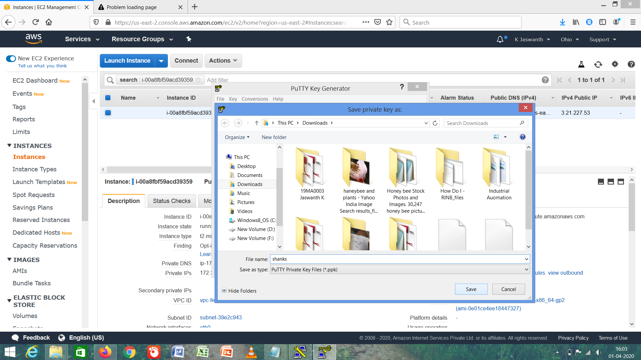

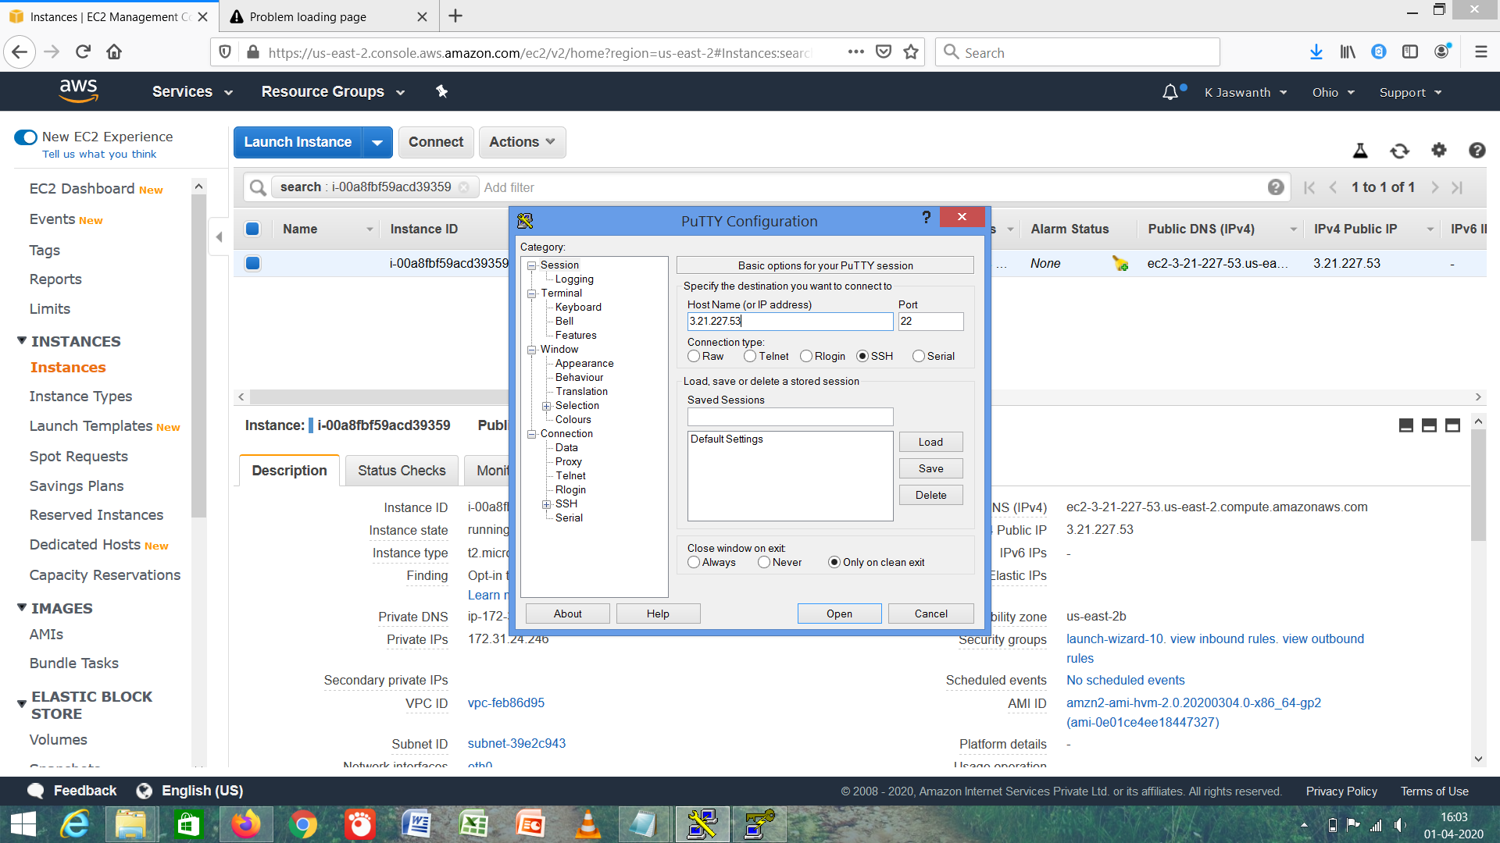

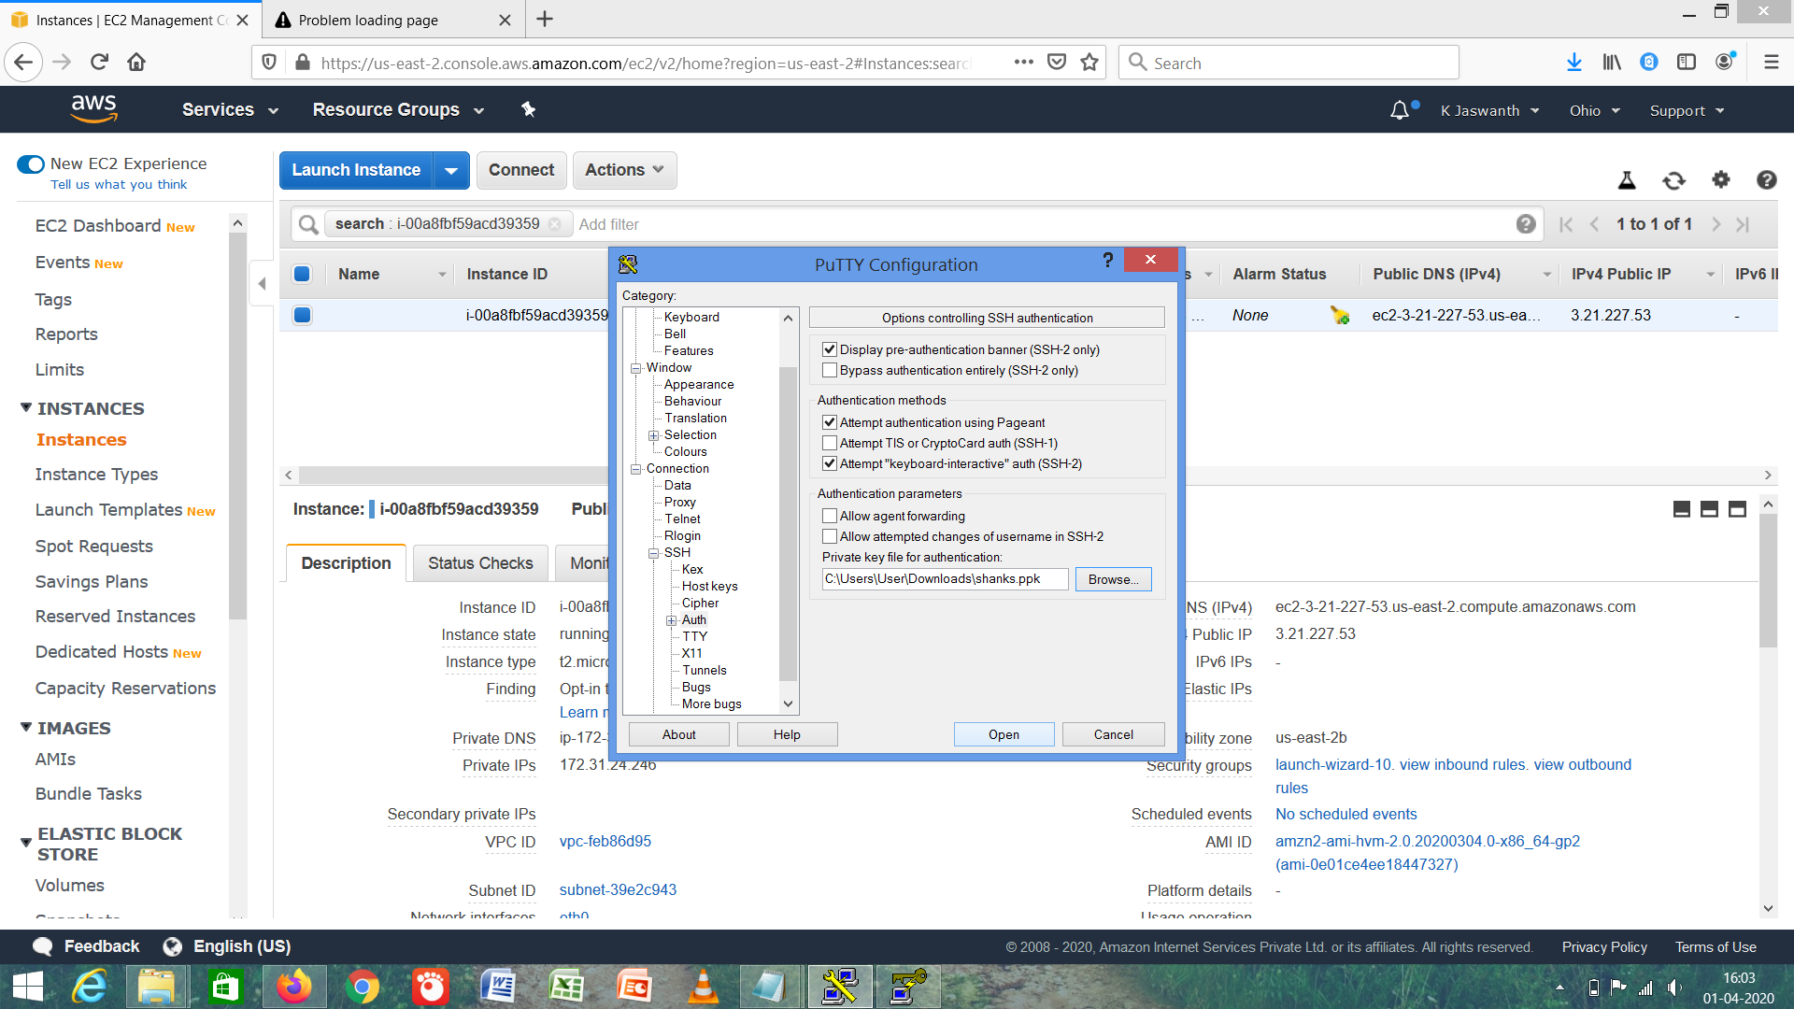

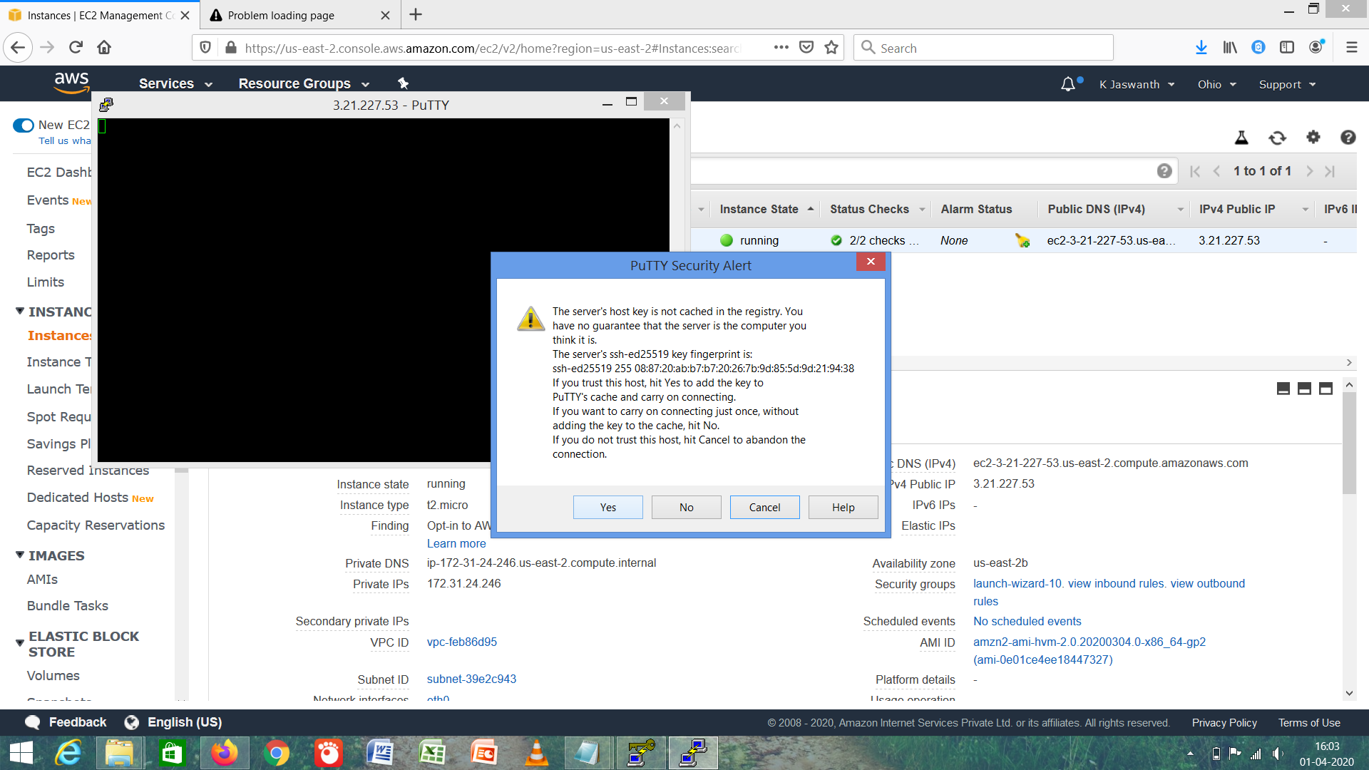

1. ***Logged In EC2 Black Screen (Black Screen)***

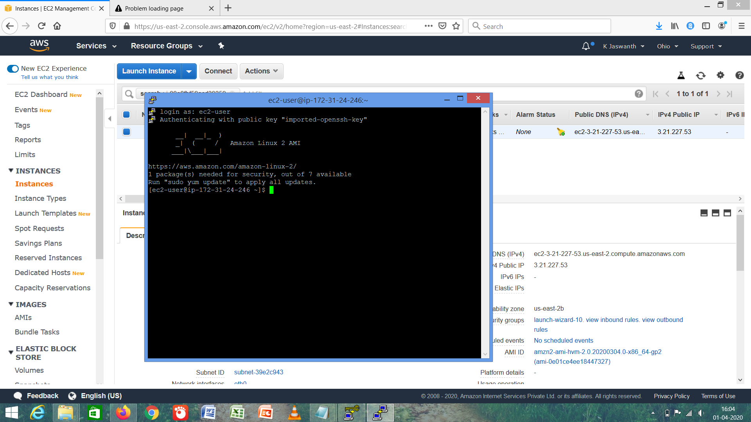

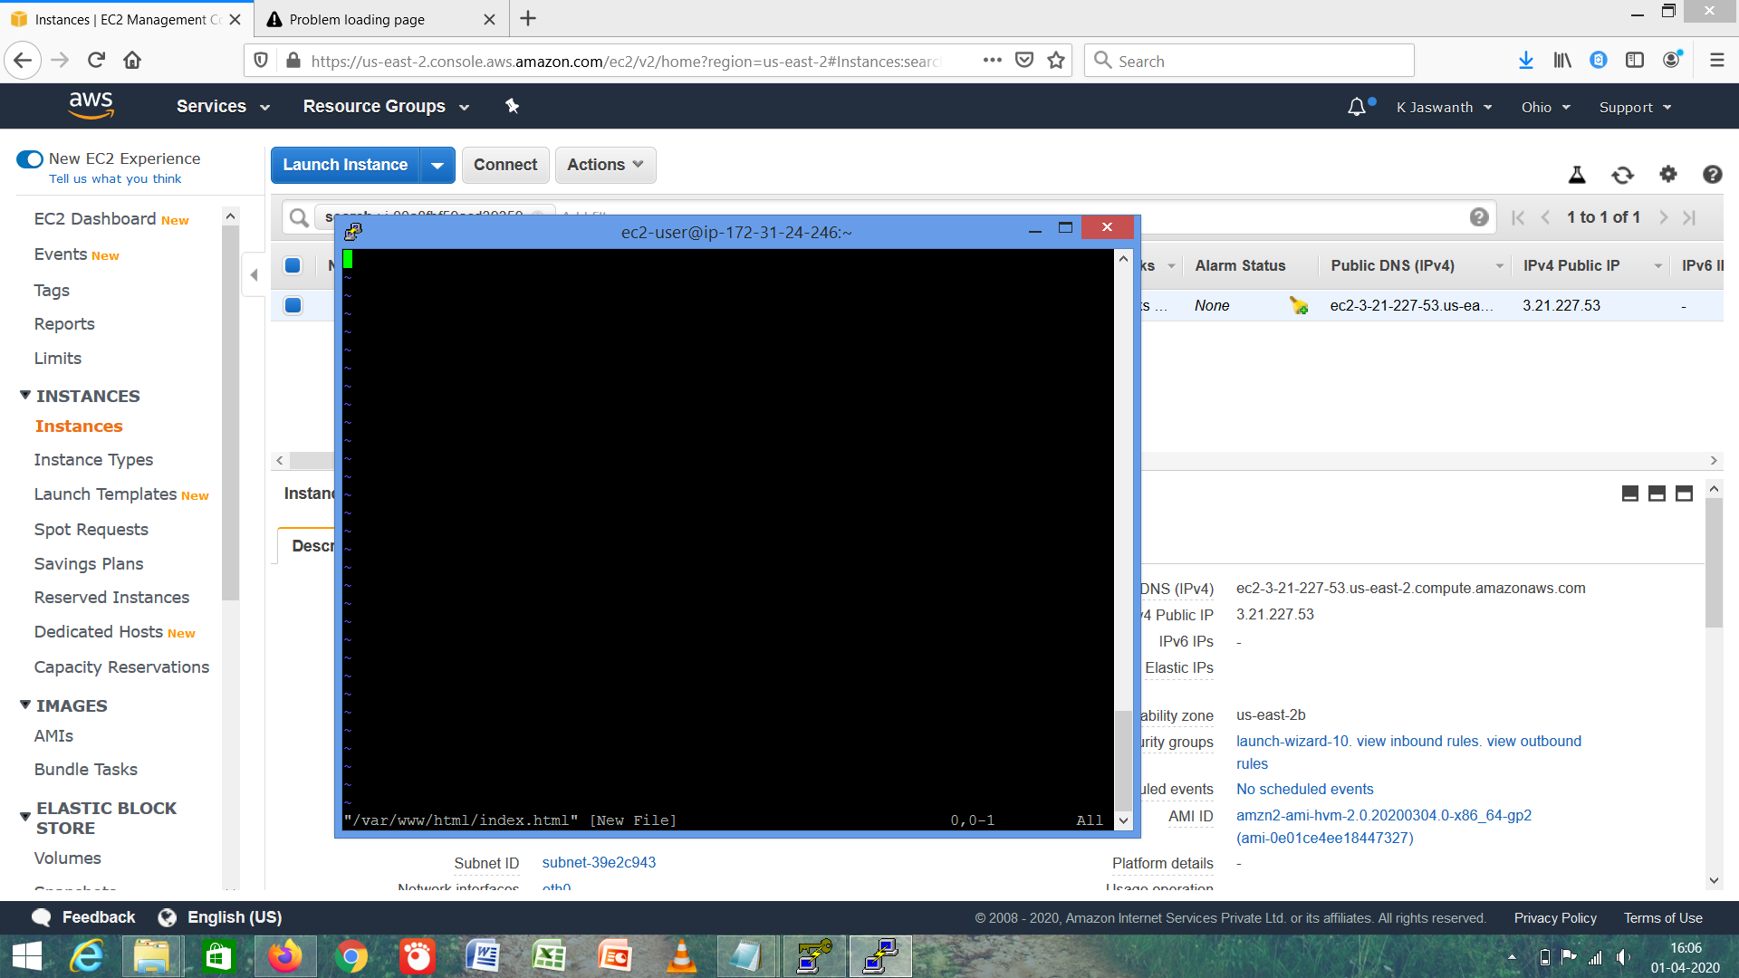

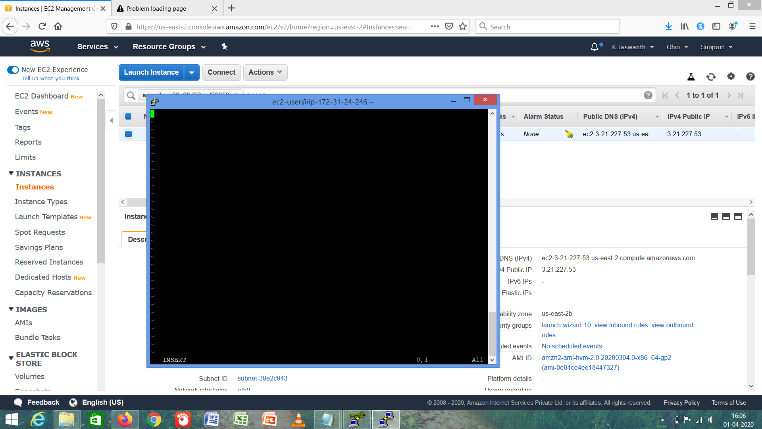

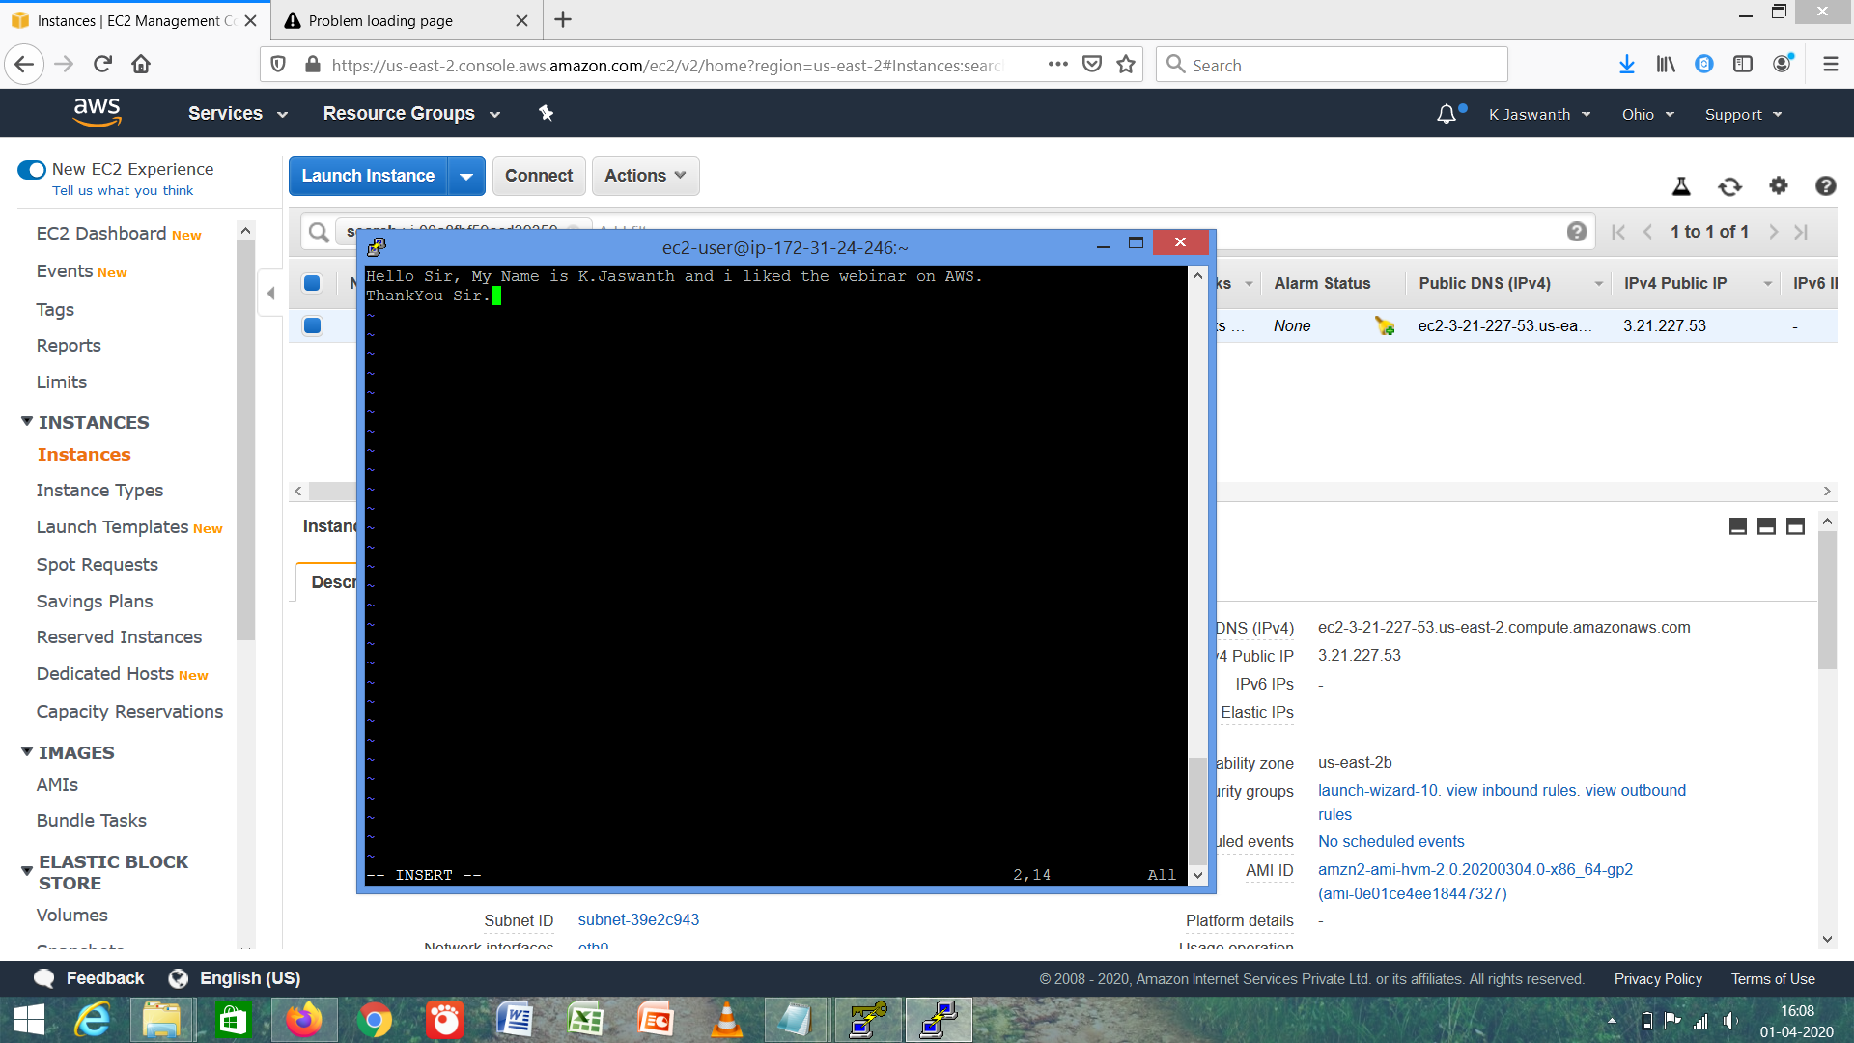

***S3 BUCKET***

1. ***Creating Bucket***

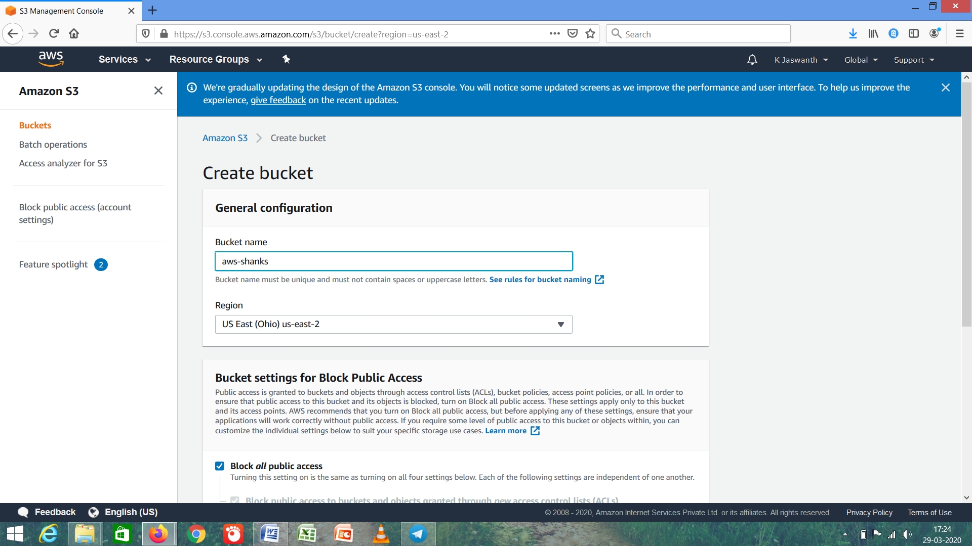

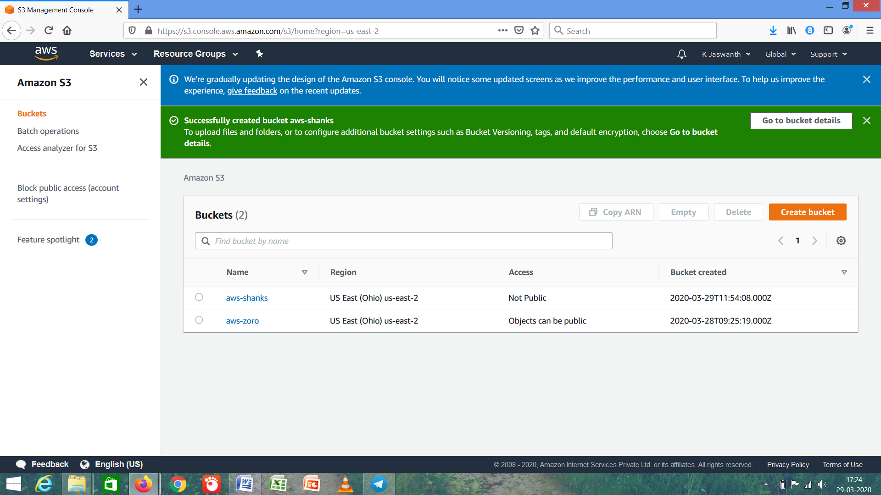

1. ***Uploading an Object***

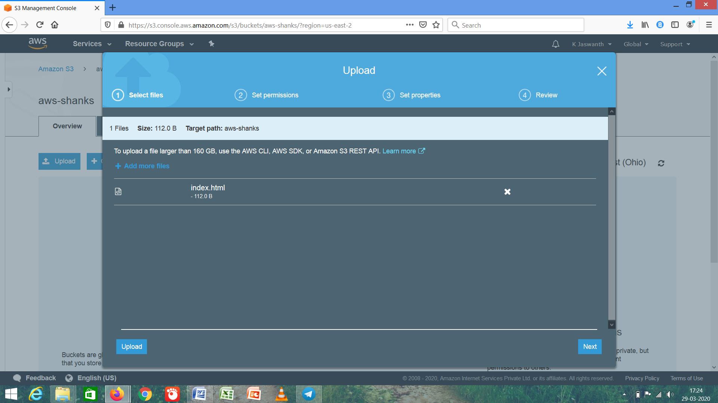

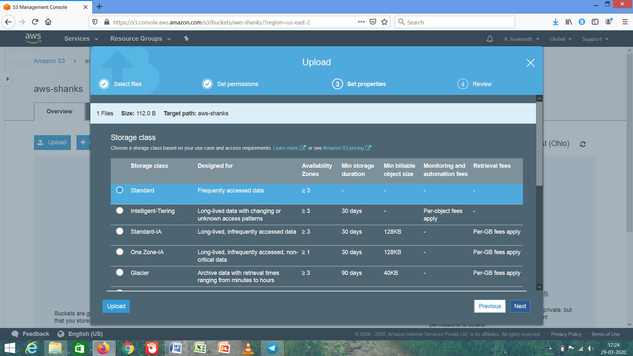

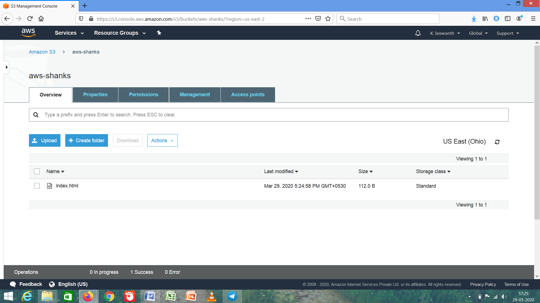

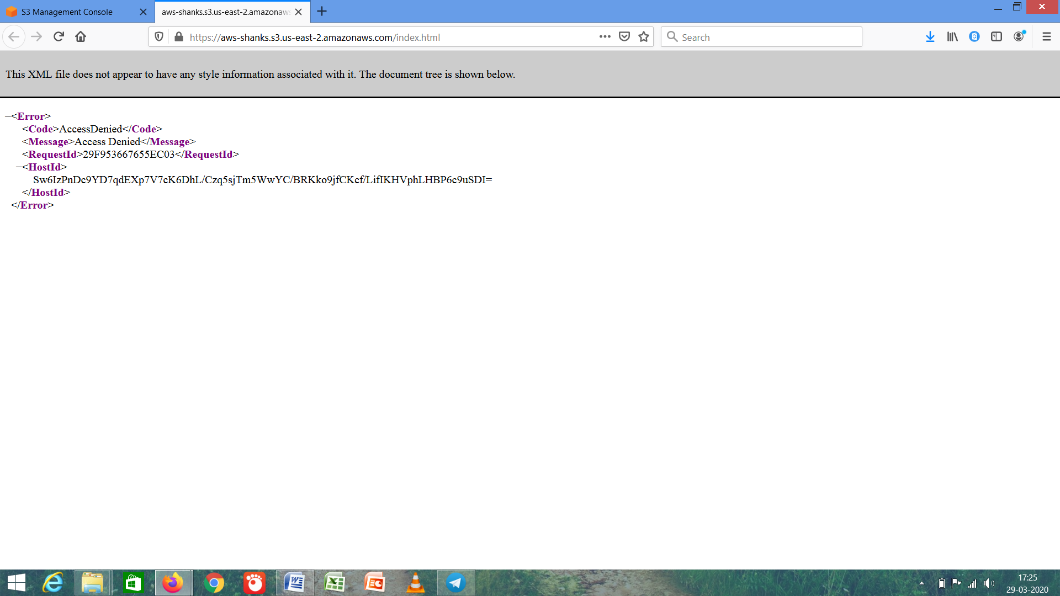

1. ***Enabling Static Website***

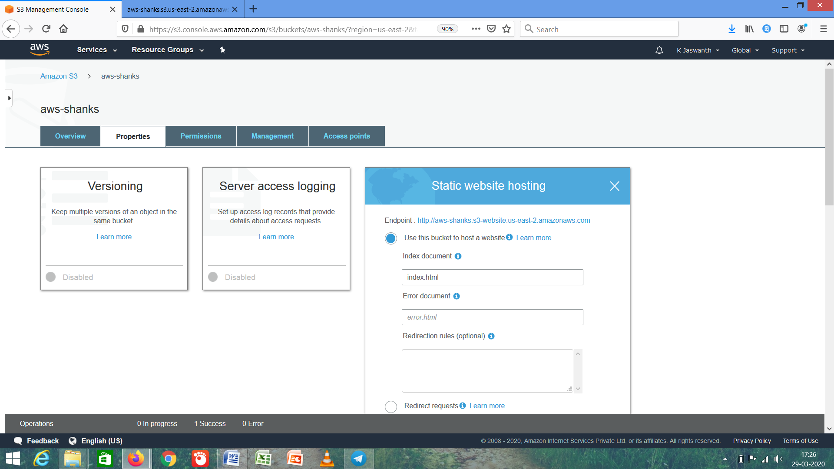

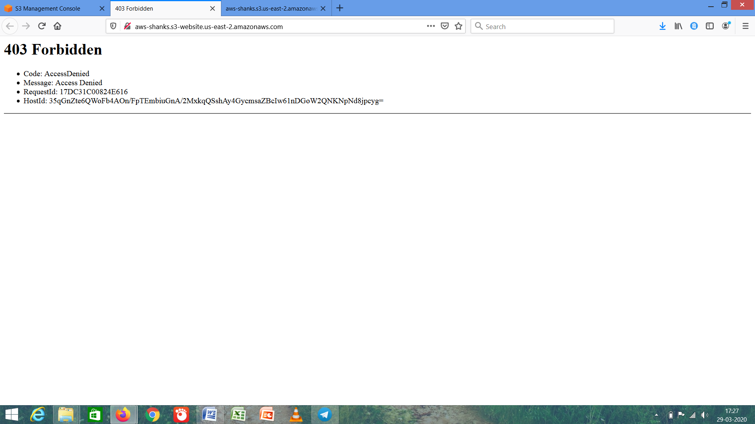

1. ***Making Object public***

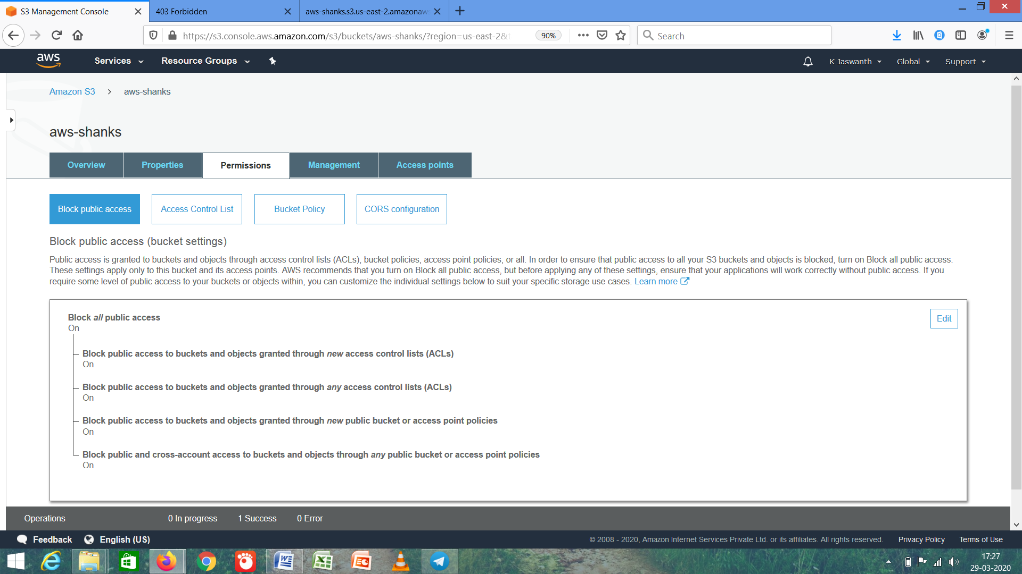

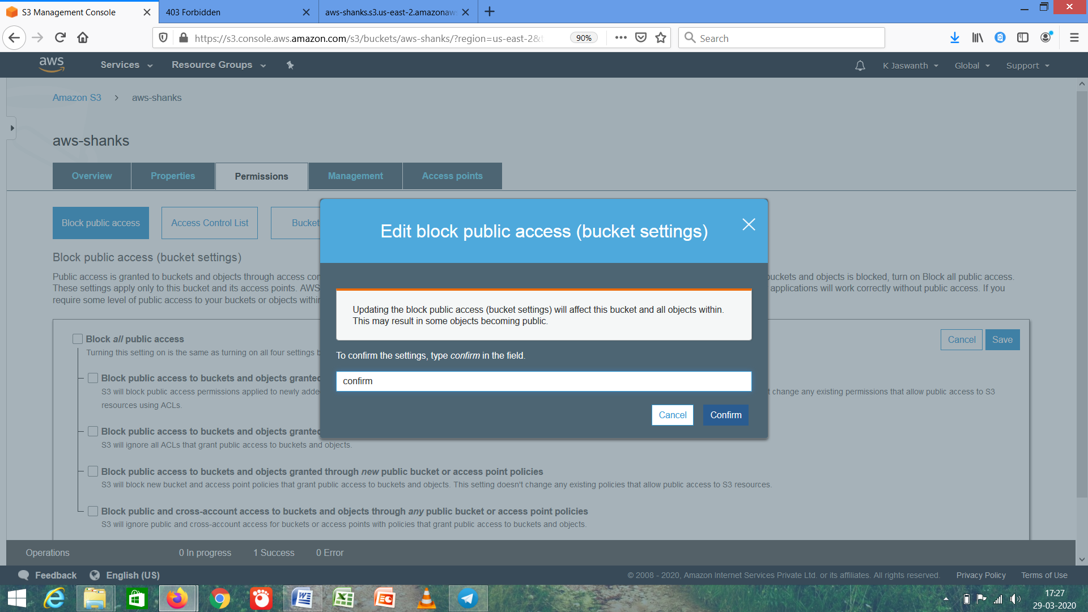

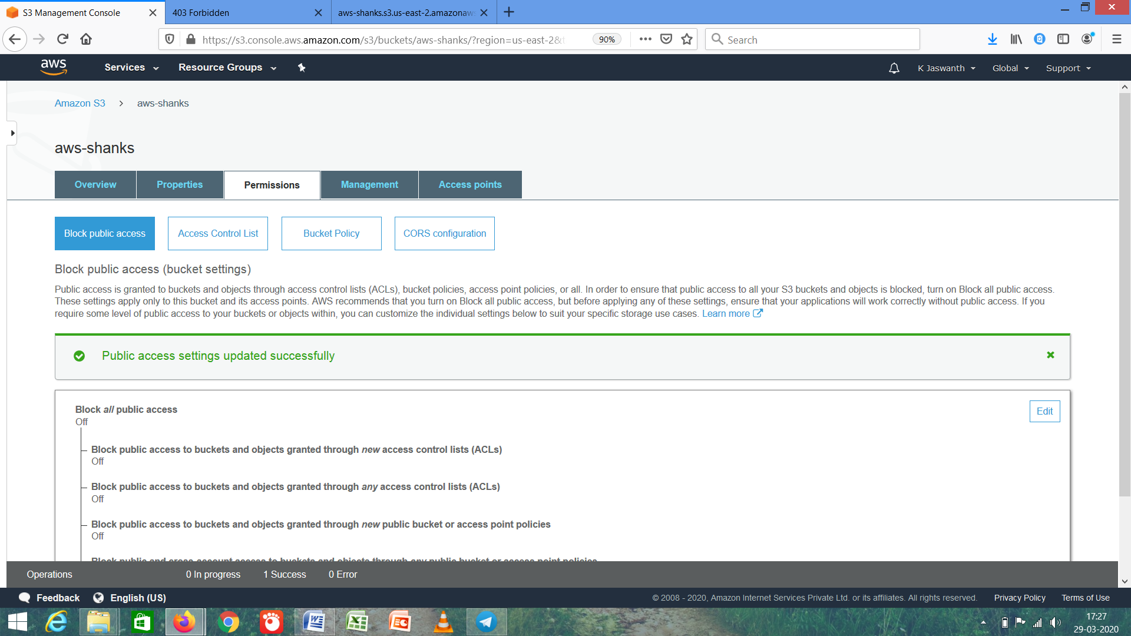

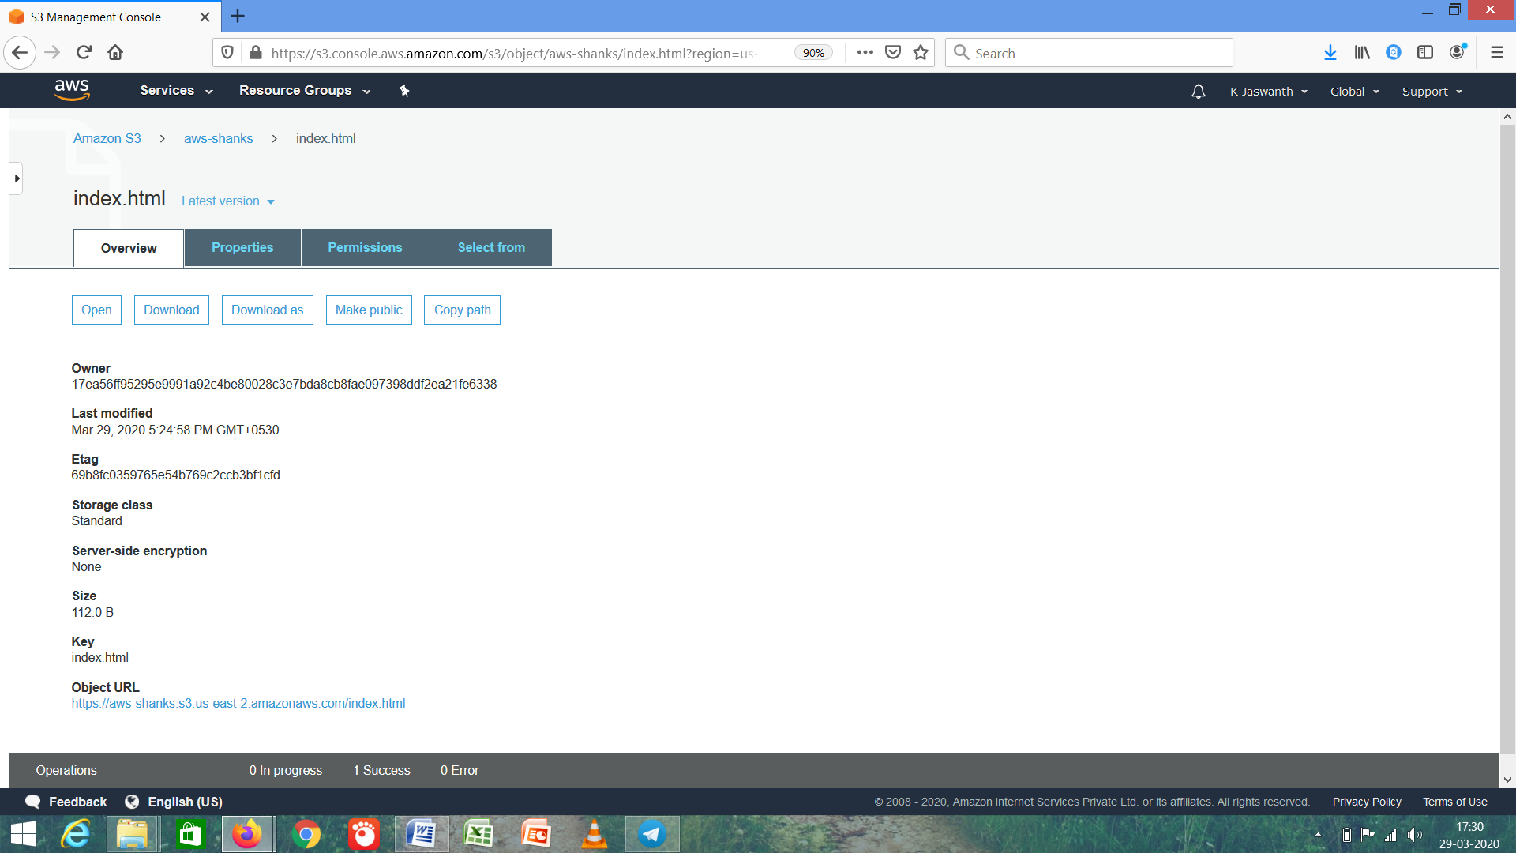

1. ***Checking S3 Link on Browser***

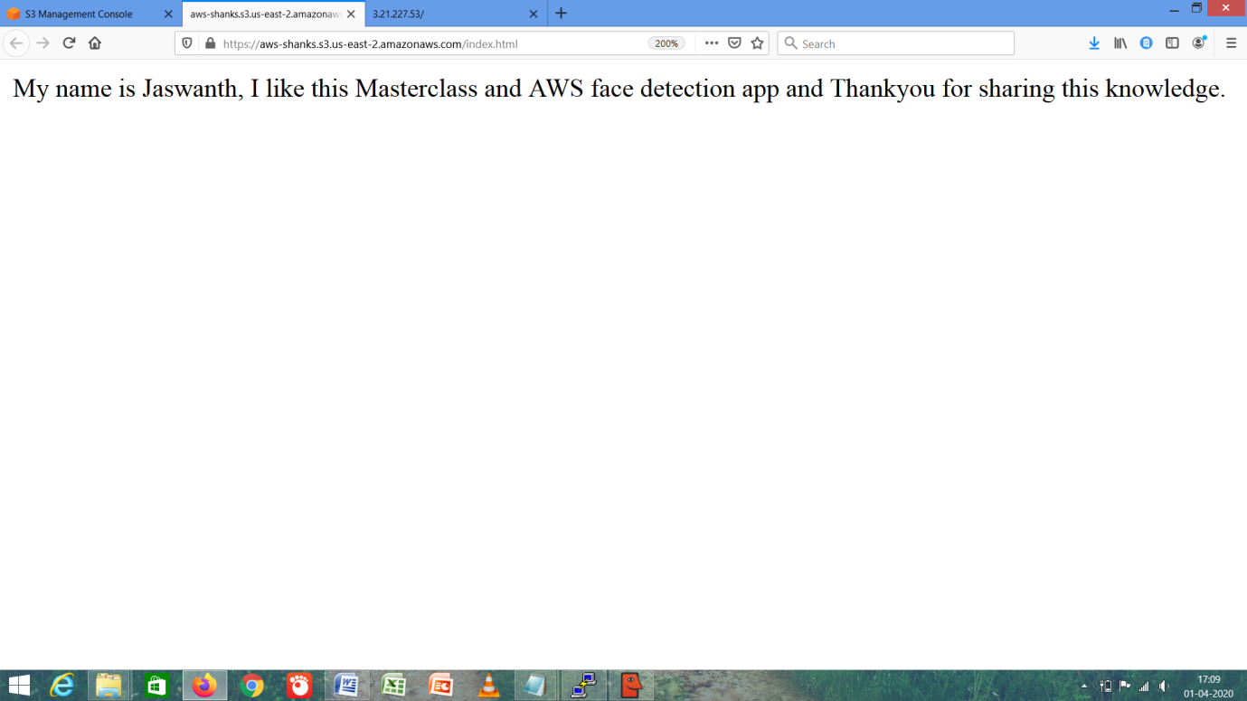

The Link is - **https://aws-shanks.s3.us-east-2.amazonaws.com/index.html**

***AMAZON REKOGNITION***

1. ***Face Detection***

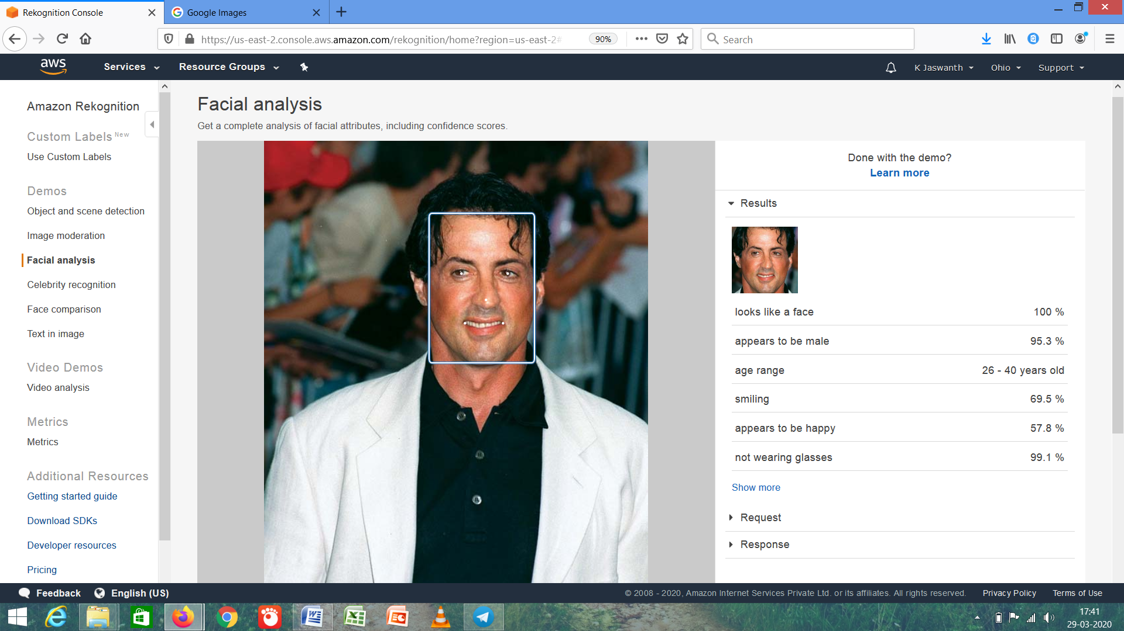

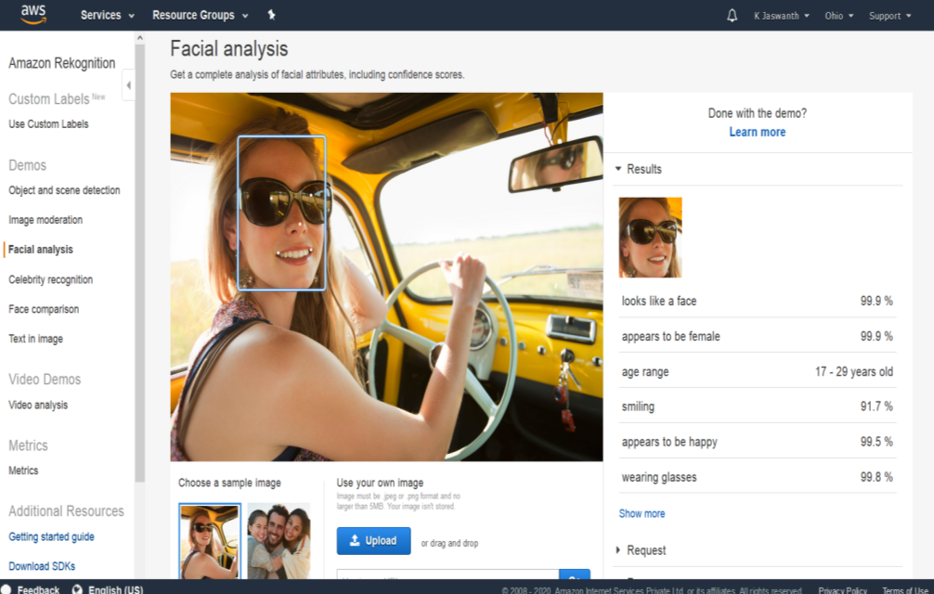

1. ***Face Compare***

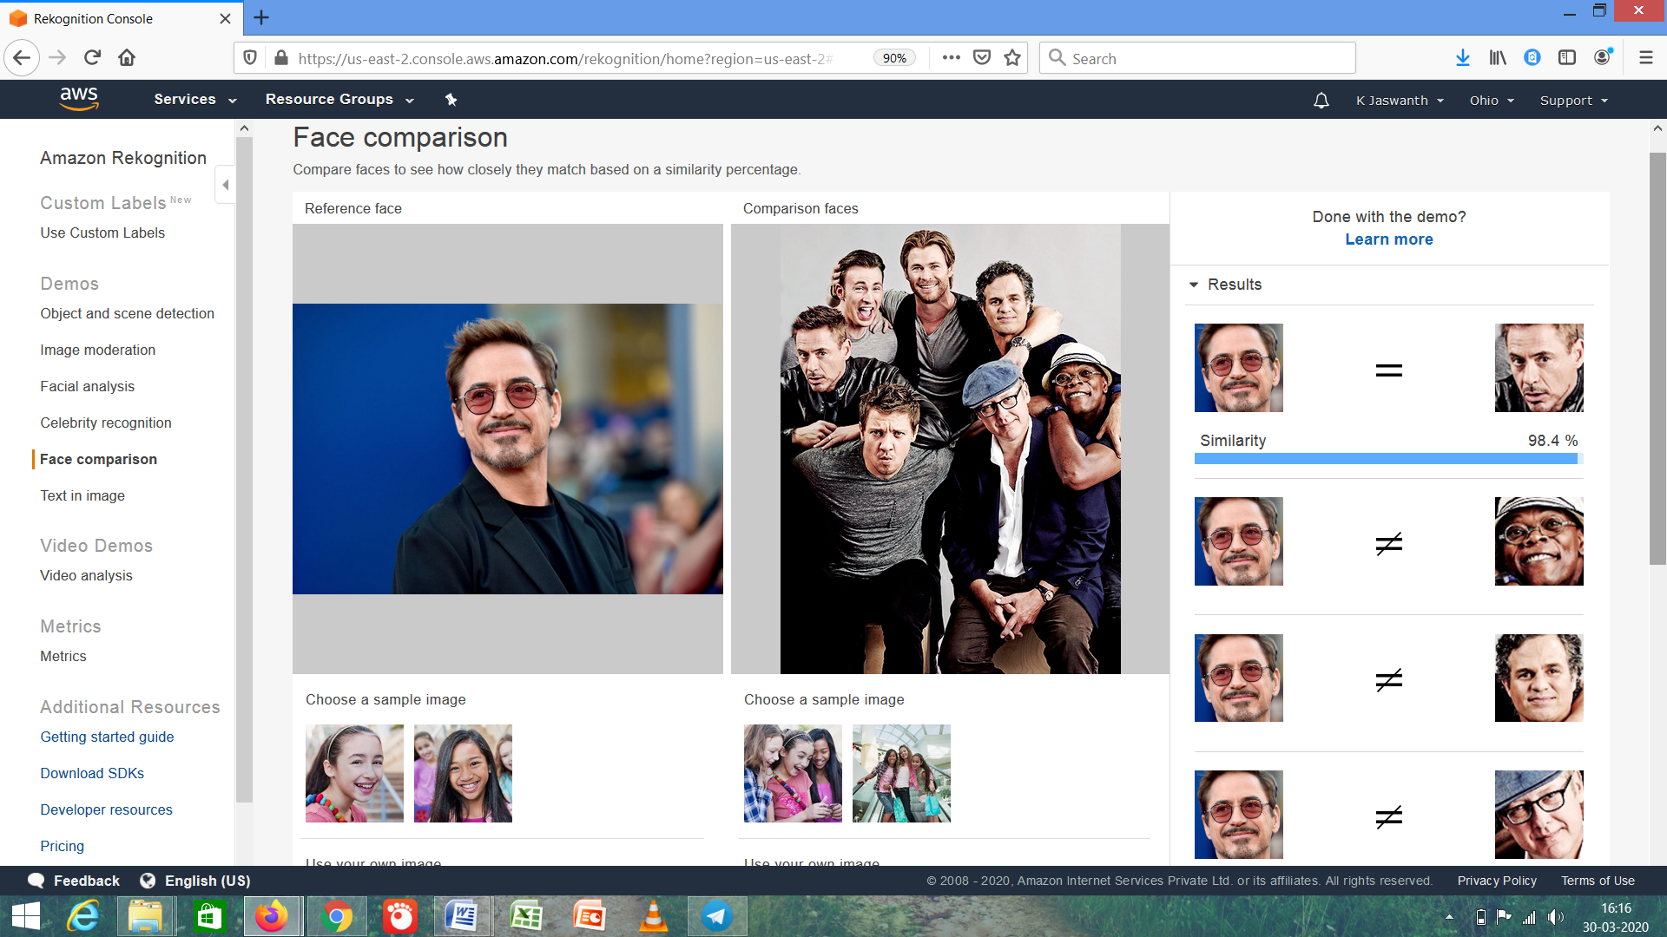

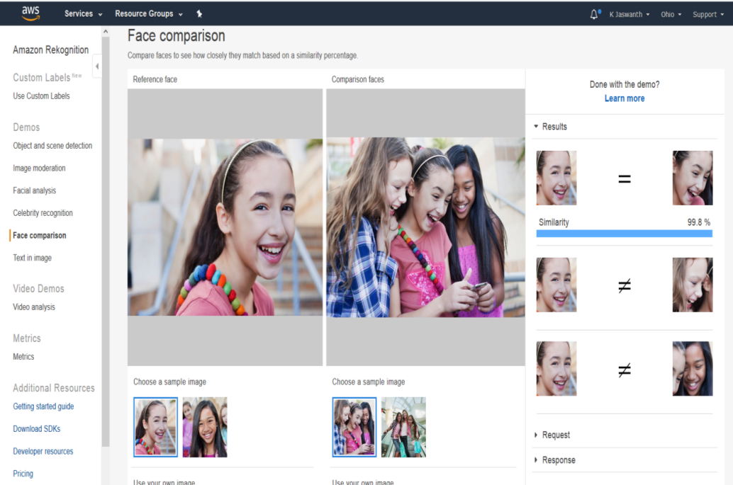

1. ***Celebrity Rekognition***

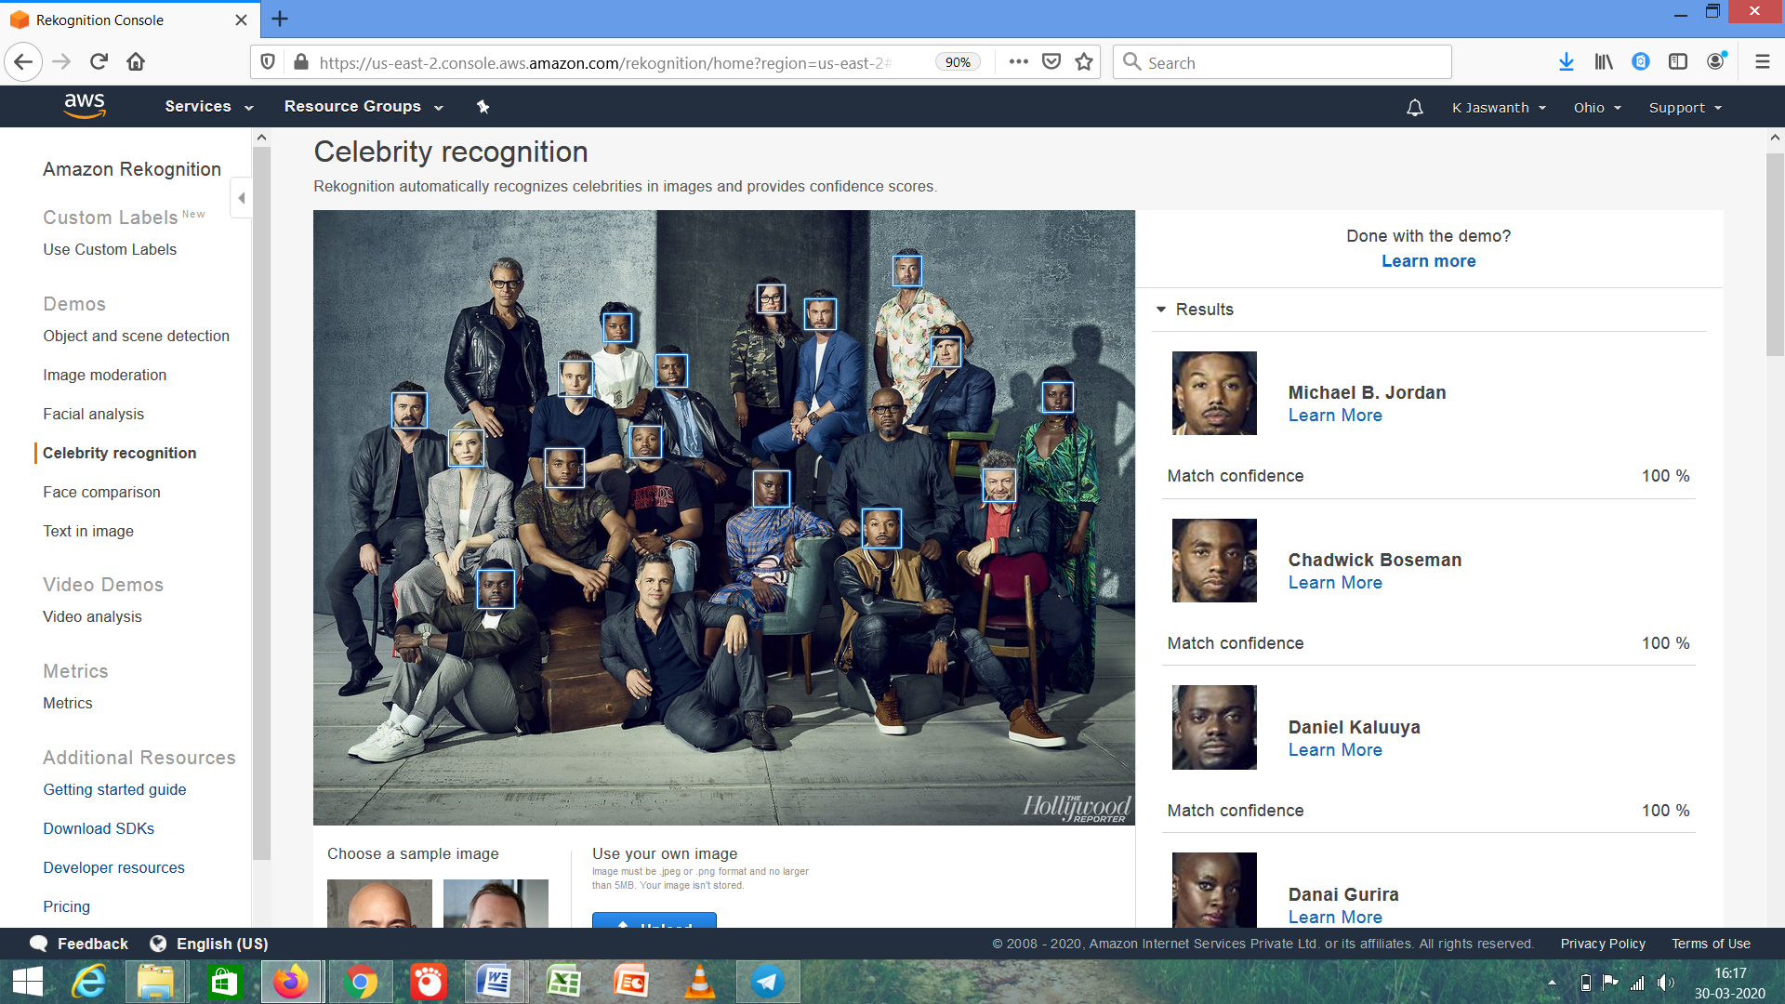

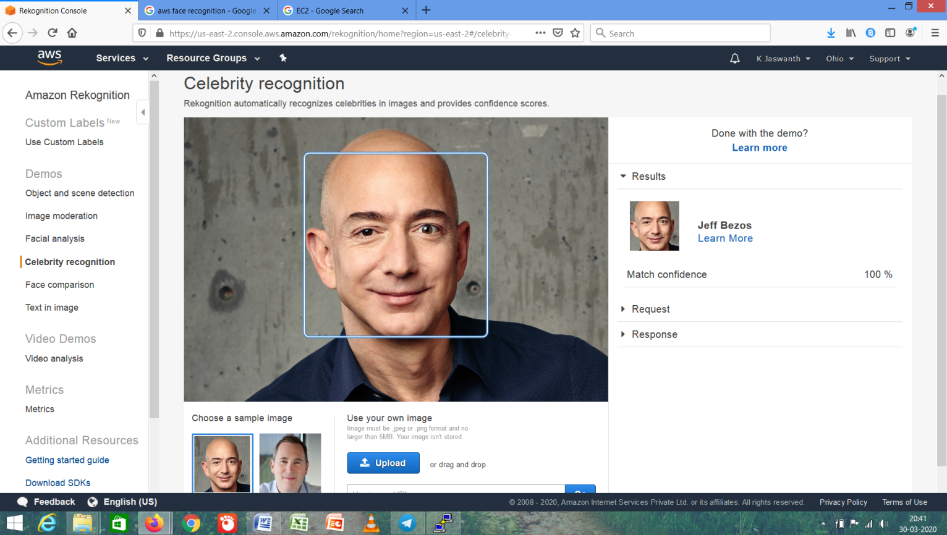

1. ***Text in Image***

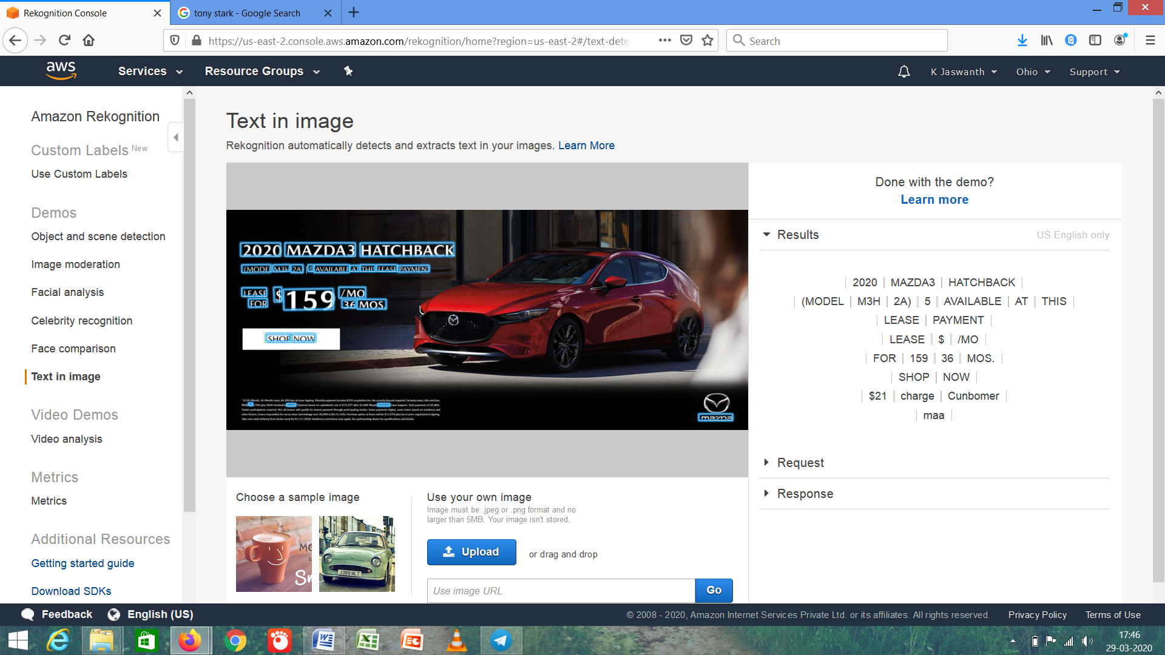

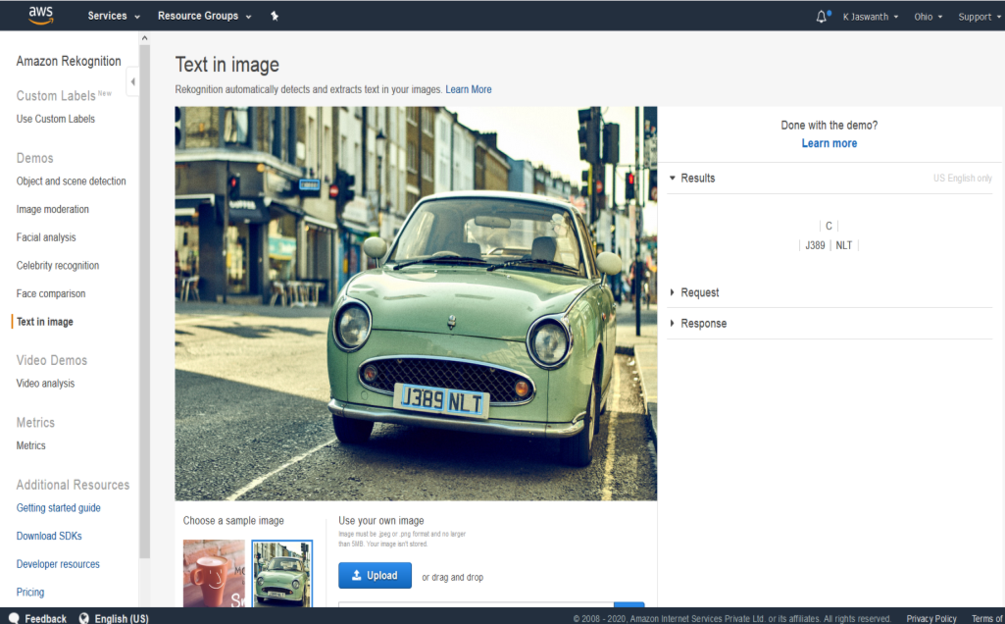

***AMAZON ELASTIC COMPUTE CLOUD (*EC2*) and S3***

1. ***Installing AWS.SDK***

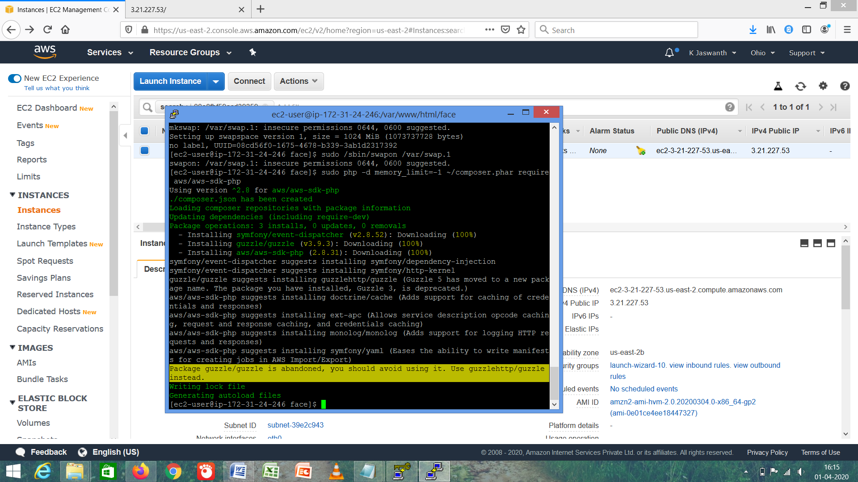

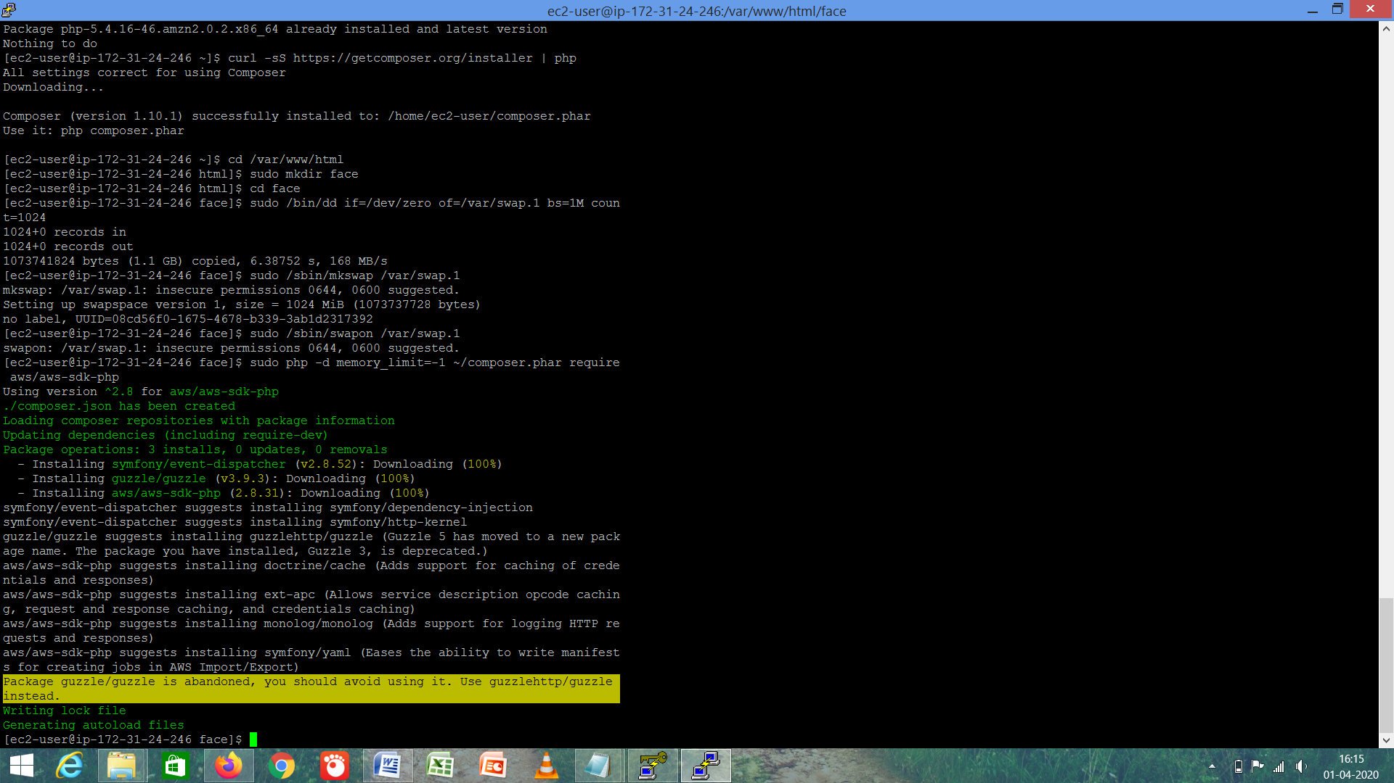

1. ***Installing PhP***

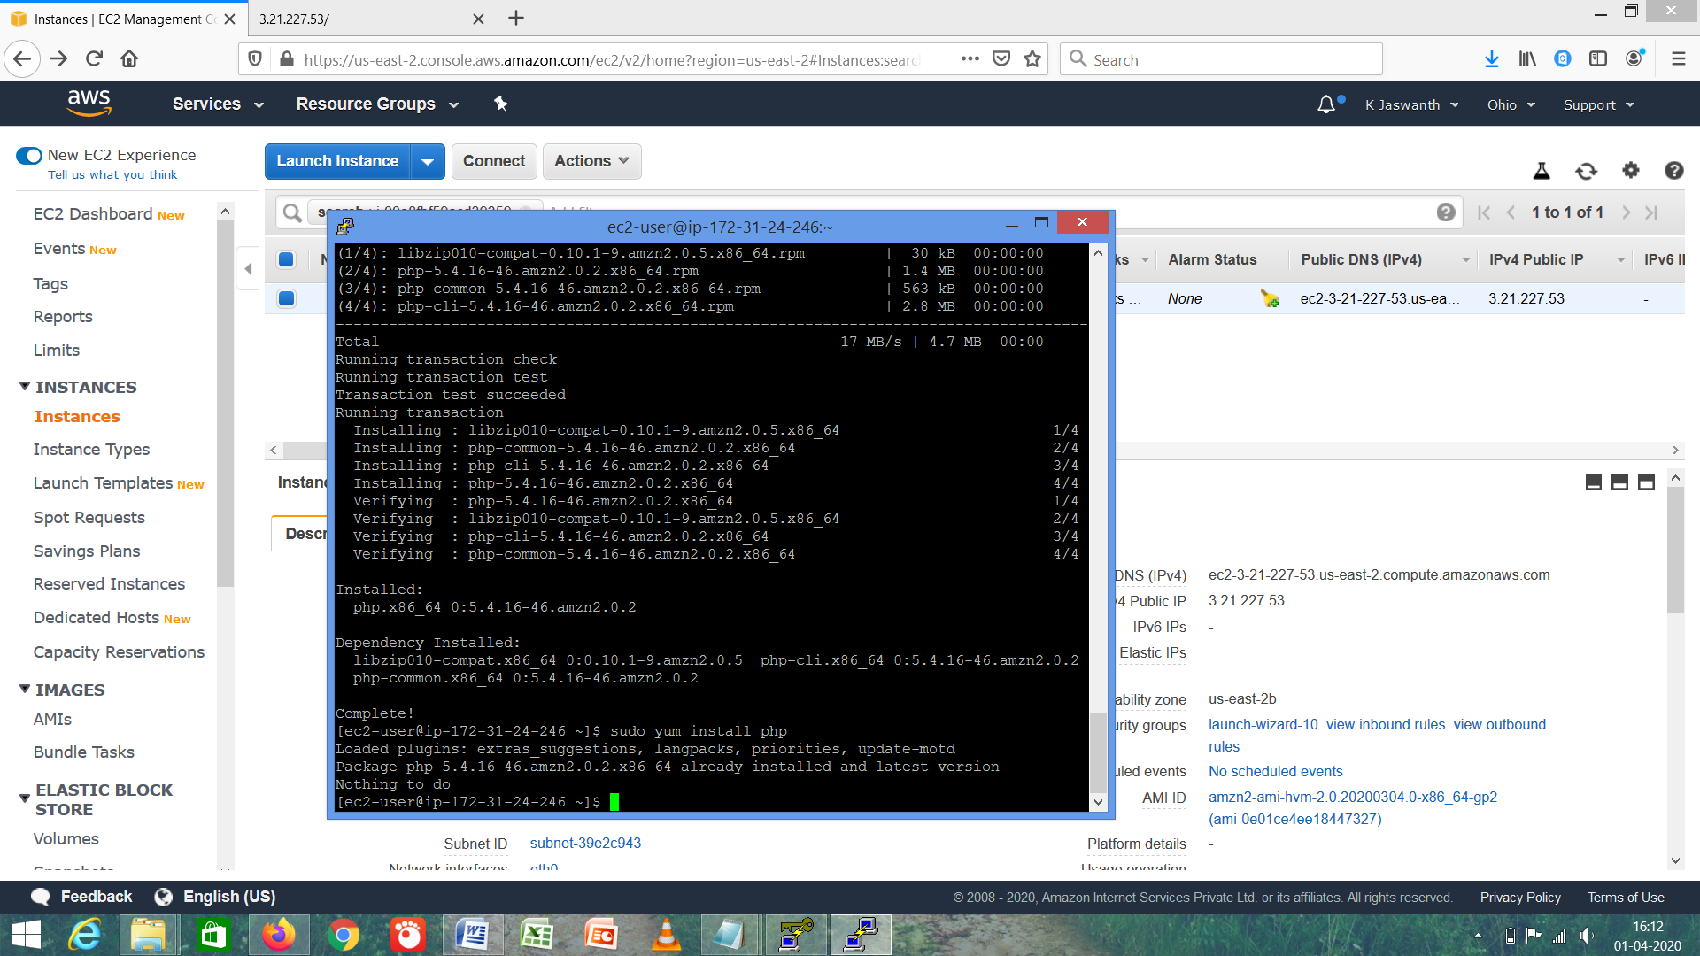

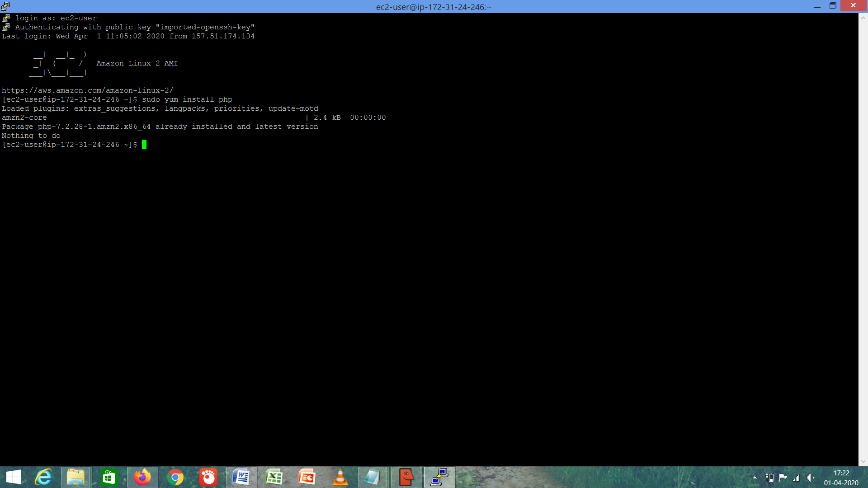

1. ***Index .PhP File Code***

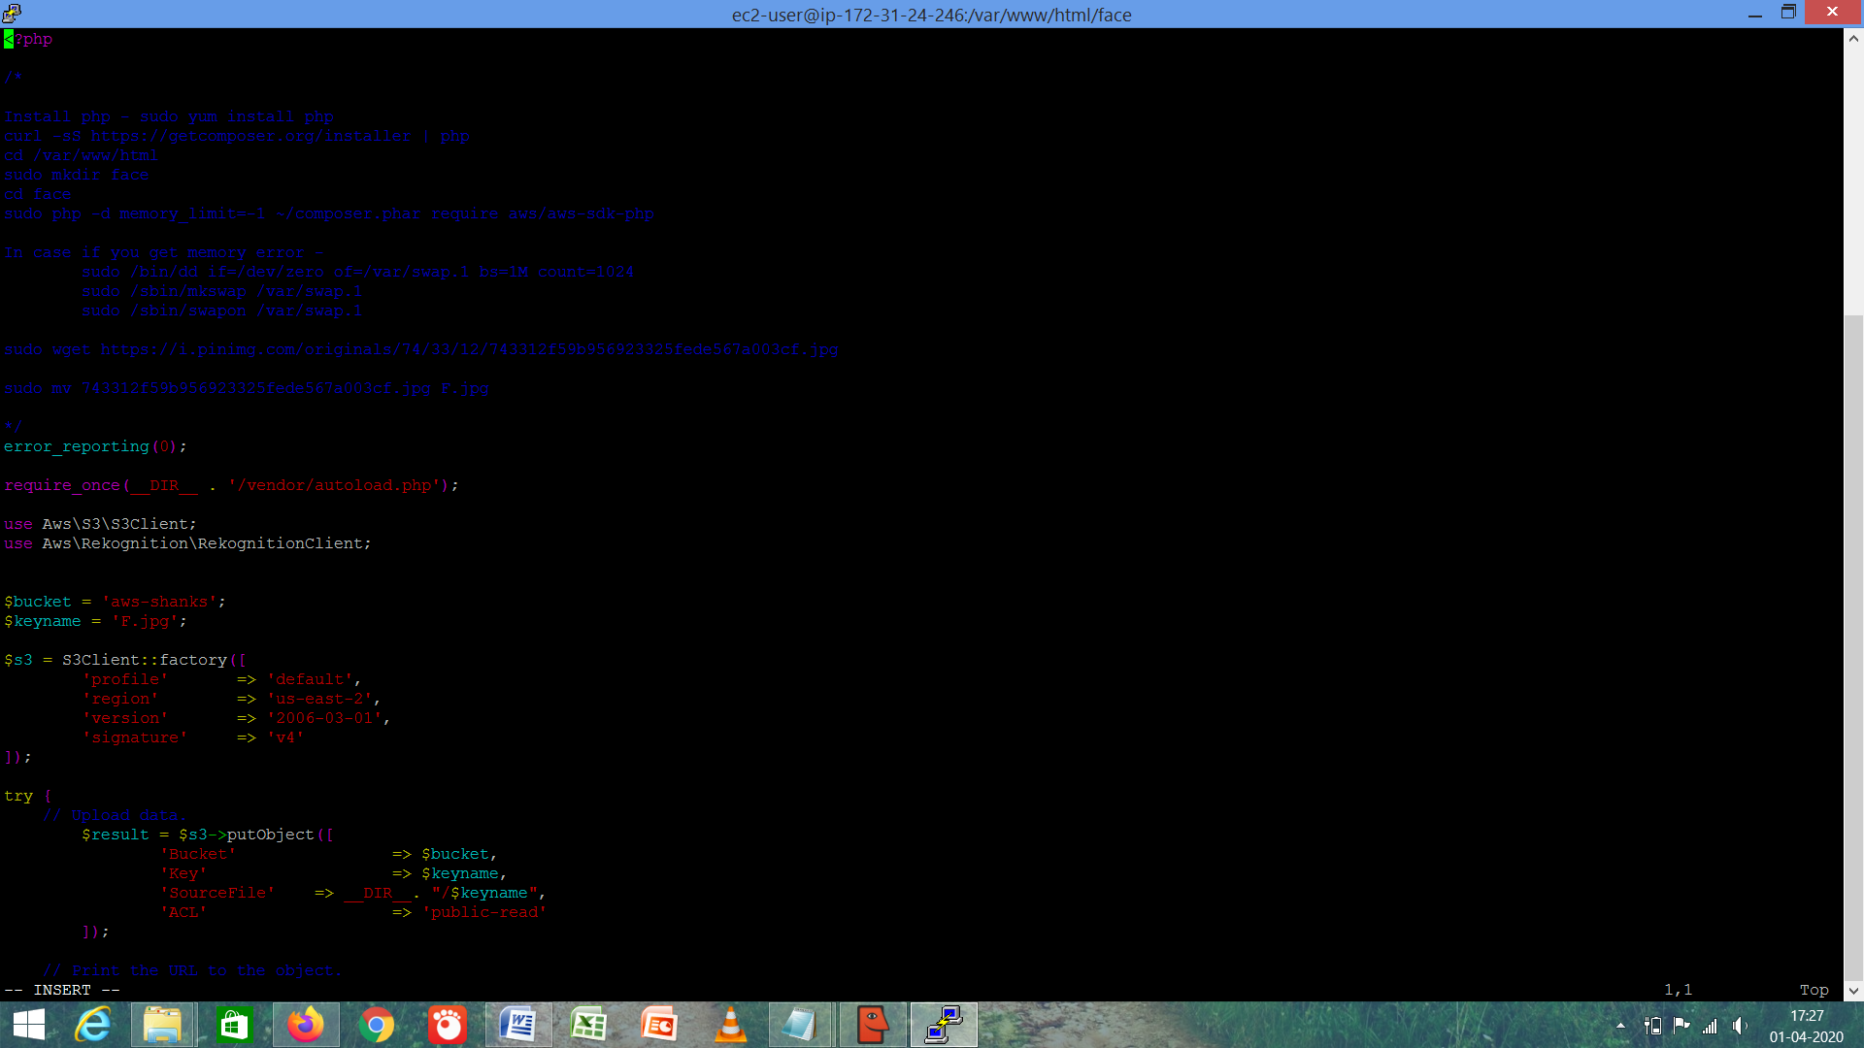

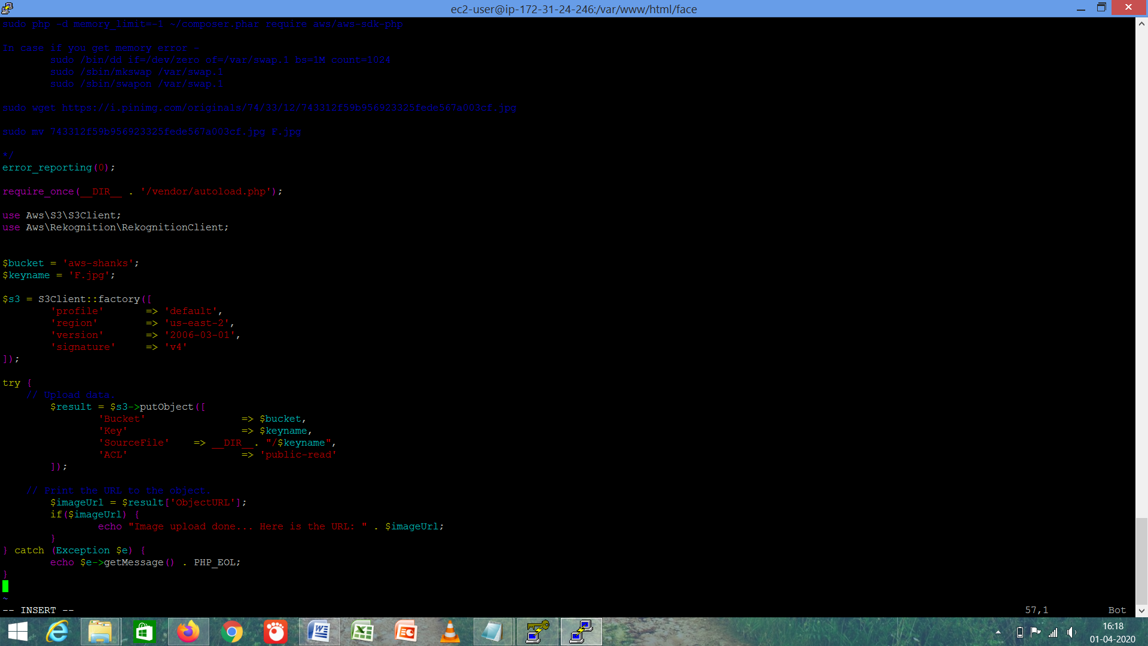

1. ***Upload Success Screenshot***

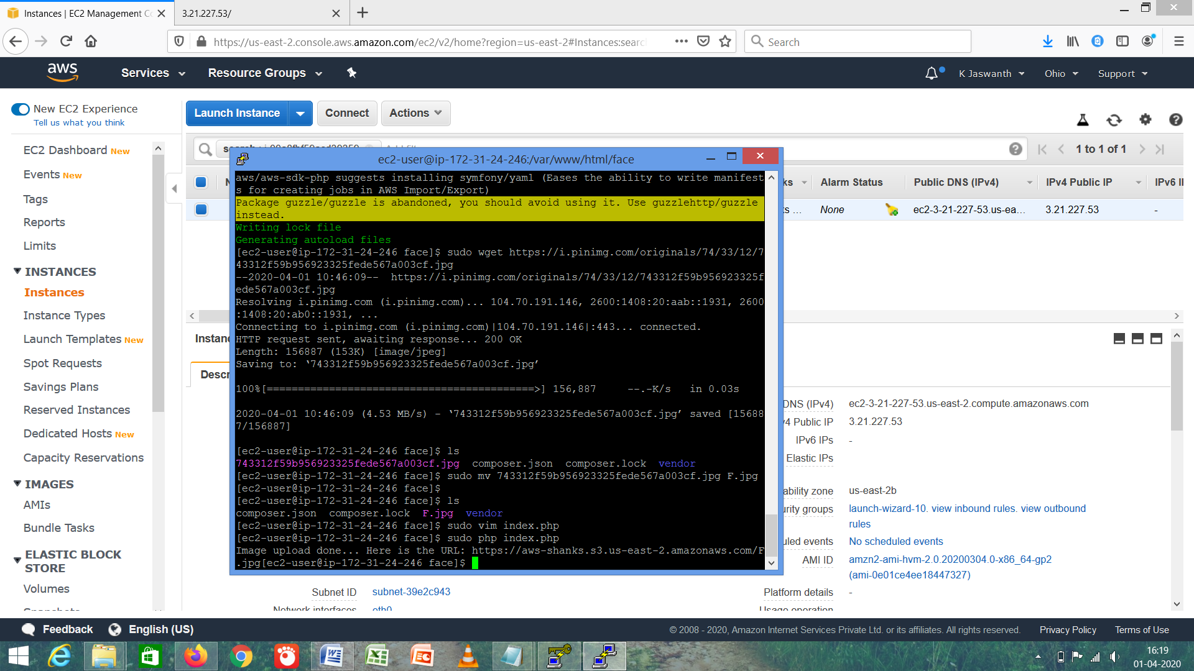

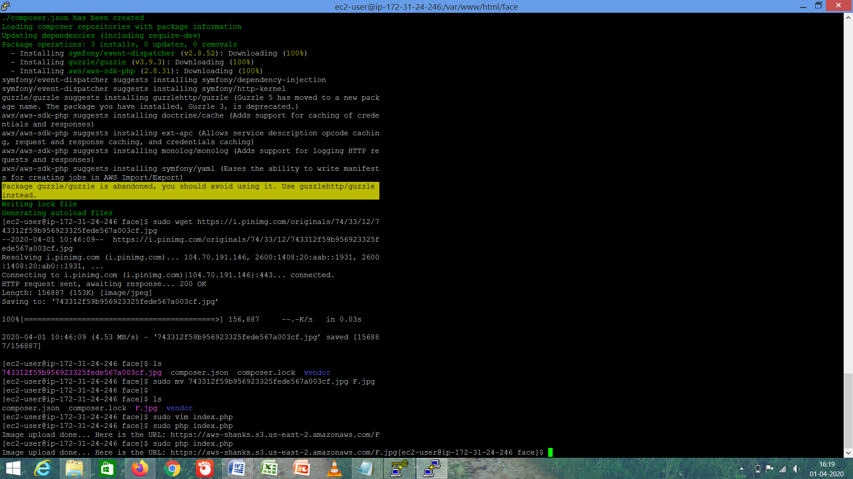

***EC2 and REKOGNITION***

* ***Face Detect Success Screenshot***

